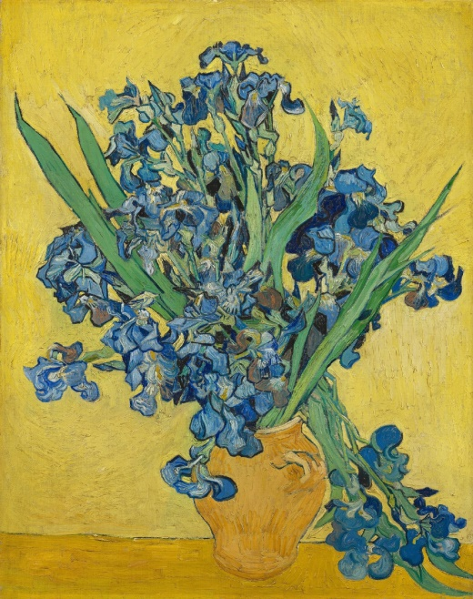
Title: Irises
Type of painting: Oil in canvas
Height and width: 92,7 cm X 73,9 cm
Year it was painted: 1890
Viewing notes: Vincent Van Gogh painted “Irises” while he was at the asylum in Saint-Rémy during his last months of life. In fact, the specific painting was mainly a study at colour in which he attained a powerful colour contrast. In this still life, the decorative forms outstand more strongly owing to the placement of the purple flowers against a yellow background. Additionally, it is worth mentioning that the depiction of flowers is reminiscent of the Japanese aesthetic. The irises, even though were initially purple, they turned blue as the pigment faded.
Feelings: The painting, immediately provokes positive feelings. Yet, Vincent created this drawing with sorrow and he didn’t manage to recover from his sadness. This contrast is truly amazing because it indicates that he was able to stimulate our optimism and happinessin spite of his depression. Having said that, this creation made by genius Van Gogh, is not a cry of emphatic pain.Consequenly, even though he was unhappy and suffered from mental disease, he didn’t disappoint us, he rendered them so well and provoked sentiments of enthusiasm and joy.

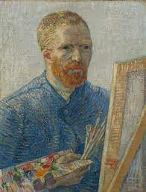
Title: Self-Portrait as a Painter
Type of painting: Oil in canvas
Height and width: 65,1 cm X 50 cm
Year it was painted: 1887-1888
Viewing notes: In the specific painting, which is a self-portrait, Vincent presented himself as a painter with his palette and his paintbrushes. The colours are bright, vivid and unblended and it is implied that he utilizes a modern way of artistic expression and a new style. The palette is contained by colour pairs that complement each other (such as blue and orange or purple and yellow) which are the precise hues he used for his painting. These pairs are laid down side by side to intensify one another.
Feelings: In the “Self-Portrait as a painter”, Van Gogh seems that attempts to portray the melancholic aspect of him. The sentiments that it provokes despite the brightness of the colours are associated with unhappiness. It helps us understand the fact that he suffered from depression at a great rate and automatically we feel symphony for him. The entire illustration makes us point out an exhausted painter who has wrinkles around the mouth and forehead, a red beard and a clear turmoil, is pretty unkempt, sorrowful and transmits these negative sentiments to people.

Stelios Alexandridis

