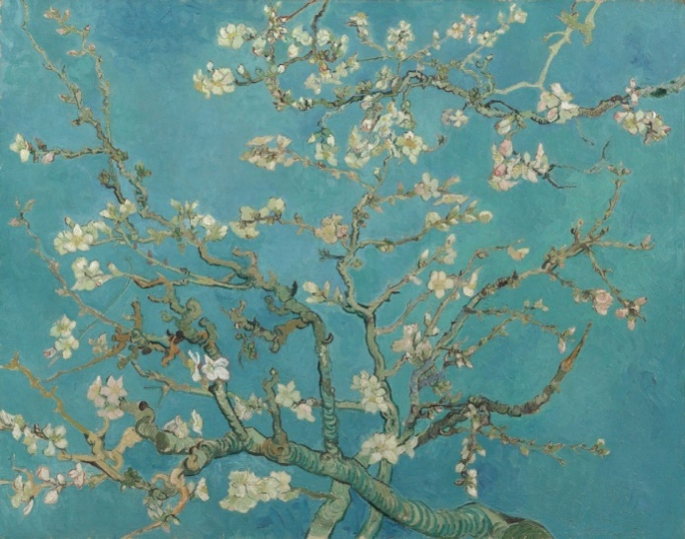
Title: AlmontBlossom
Type of painting: Oil in canvas
Height and width: 73,3 cm X 92,4 cm
Year it was painted: 1890
Viewing notes:Large blossom branches like this against a blue sky were one of Van Gogh’s favorite subjects. Almond trees flower early in the spring making them a symbol of new life. Van Gogh borrowed the subject, the bold outlines and the positioning of the tree in the picture plane from Japanese printmaking.
The painting was a gift for his brother Theo and sister-in-law Jo, who had just had a baby son, Vincent Willem. In the letter announcing the new arrival, Theo wrote: ‘As we told you, we’ll name him after you, and I’m making the wish that he may be as determined and as courageous as you.’ Unsurprisingly, it was this work that remained closest to the hearts of the Van Gogh family. Vincent Willem went on to found the Van Gogh Museum.
Feelings: By seeing this painting which is one of Van Gogh’s masterpieces in my opinion, I feel extremely glad and full of delight. Moreover, it makes me joyful and it eliminates my stress.

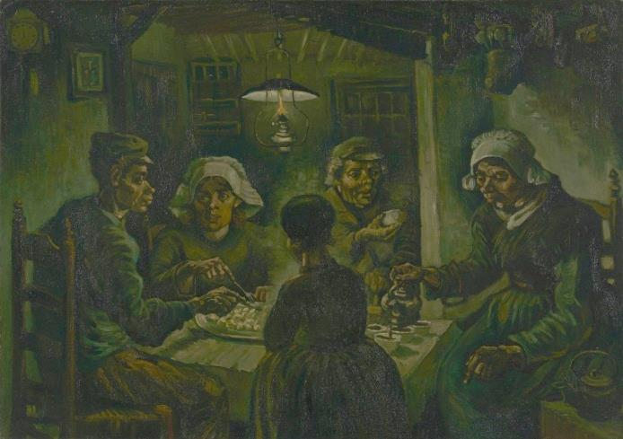
Title: The Potato Eaters
Type of painting: Oil in canvas
Height and width: 82 cm X 114 cm
Year it was painted: 1885
Viewing notes:Van Gogh saw the Potato Eaters as a showpiece, for which he deliberately chose a difficult composition to prove he was on his way to becoming a good figure painter. The painting had to depict the harsh reality of country life, so he gave the peasants coarse faces and bony, working hands. He wanted to show in this way that they “have tilled the earth themselves with these hands they are putting in the dish ... that they have thus honestly earned their food”.
Feelings: The potato eaters provoke to me feelings that are associated with depression and sadness. By seeing the pain on the potato eaters’ faces that are faded by the time, I instantly received sadness and melancholy.

John Alexandridis

