  - ‘’My Vincent Van Gogh’’
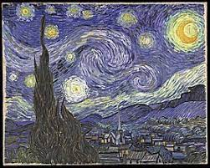
  - Vincent Van Gogh was a Dutch painter and generally considered to be one of the greatest Post-Impressionist. He sold only one of his artworks but after his death he has earned much more reputation and got recognized as a painter.
  - He was born in a village in the Brabant region of the southern Netherlands. He had a great connection with his family and especially with his brother Theo. He discovered Impressionist painting which influenced him a lot and especially where he was enrolled, in the Antwerp Academy. In 1886 Vincent moved to Paris with his brother Theo and he also met Emile Bernard and Paul Gauguin. In 1888 he created his own style of brushwork. This included a brighter use of colors and lighter tonalities. Van Gogh’s style was spontaneous and instinctive, for he worked with great speed and intensity, determined to capture an effect or a mood while it possessed him.
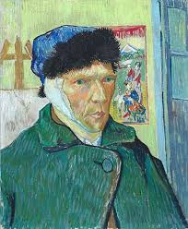
  - The disaster struck on Christmas Eve in 1888. He had an argument with his friend Gauguin. Specifically he chased him with a razor and cut off the lower half of his own left ear. His problems with his mental health didn’t stop until at the end of April 1889 he asked to be shut up in the asylum at Saint-Rémy-de-Provence in order to be under medical supervision. Inside the asylum he created 150 paintings. When he left the asylum he went near Paris to a doctor Paul Gachet and also wanted to be in touch with his brother Theo who recently got married. Van Gogh drew the portrait of Dr.Gachet. On July 27 Van Gogh shot himself in the chest and died two days later. Six months later his brother Theo died unable to come to terms with his brother’s death. Van Gogh’s love for his brother was shown by the letters that the painter was sending him.
  - Van Gogh’s work recognized after his death and a painting called ‘’Dr.Gachet’’ was sold at the exceptional price of 82.5$ million establishing a new price record. Although he suffered a lot with his mental health he had also some happy times like with his brother.

