Maria Dara A3
19/1/25

MY VINCENT VAN GOGH

Everyone has heard at least once in their lifetime the name ‘’Vincent Van Gogh’’. But what they seem to ignore is his obscure life in which his contribution to art remained unrecognized. For this reason, I decided to write this article, talking about his perspective on life and some of his artworks that I truly admire.
To begin with, Vincent Van Gogh was born on March 30, 1853, in Zundert, Netherlands. He was the son of a Protestant pastor and the eldest surviving child in his family. At first, Van Gogh worked as an art dealer, a teacher, and a lay preacher before dedicating himself to art at age 27. He painted for about a decade and he produced a remarkable amount of art works (approximately 900 paintings). It’s true that he struggled with many mental health problems including depression and psychosis and he even spent some years in an asylum in Saint-Remy. There are many theories from now day doctors that assume that he suffered from epilepsy or even bipolar disorder. Taking all of these into consideration, it would be interesting to take a closer look at his point of view.
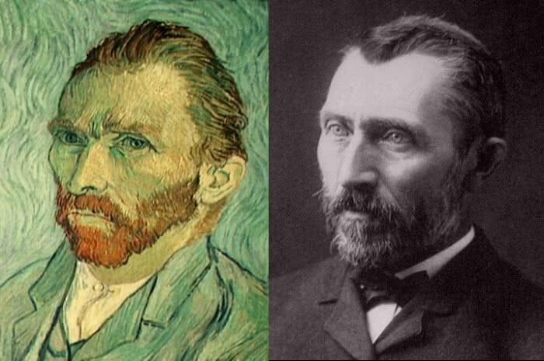

Growing up in a very religious environment, Van Gogh had developed a very melancholic, passionate, spiritual view on life. Through art and especially through painting and writing he found a way to express his inner feelings and the complex, emotional essence of life. He believed that through his art, he could reveal the beauty of life, even in its suffering. His connection to God was also reflected in his respect for nature. He was deeply inspired by nature and found peace in it’s beauty. He believed that nature can heal the soul and mind. Moreover, he felt deep compassion and love for people and especially the working class. He admired their strength and recognized their suffering and their labor. Although he found happiness and pleasure in the small things of life he often felt disconnected and misunderstood by the rest of the world. He battled with loneliness and even though he valued love and human connections he struggled to find them in his own life. Day after day, he was sinking more and more in the depths of isolation, despair and hopelessness. That’s until he decided to take his own life on July 27 1890 by shooting himself with a gun. Two days later, on July 29 he died. After his death, his artworks started getting the attention they deserve and now he is one of the most famous painters in the world.

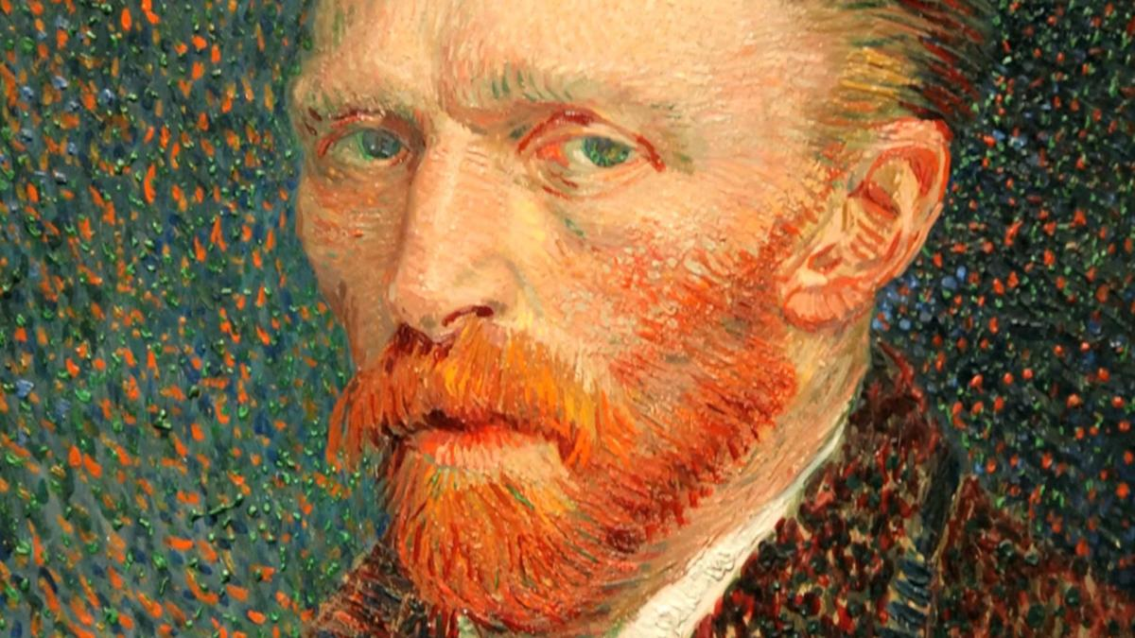
As previously mentioned, Van Gogh in his lifetime managed to paint about 900 paintings. Undoubtedly, each one of them has its own artistic value but I am going to talk about one of my favorites. I am referring to ‘’ Head of a peasant’’ and ‘’Café Terrace at Night’’. The former, highlights humanity. In the man’s face we can capture his raw emotions that depict the roughness and the challenging conditions of that time. I admire it because the painter doesn’t idolize as he focuses on the imperfections of this man’s portrait. The latter makes me feel comfort as it evokes senses of warmth, calmness and peace. It seems like Van Gogh not only froze the time but also the emotions and with the depth that the painter uses it feels like it invites you in. It’s like it stands like a bridge between the past and the present.
In conclusion, Vincent Van Gogh is one of the most important people when it comes to art. He should be admired not only for his contributions to art but also for his ability to express his innermost emotions and struggles through his work. He still inspires artists to this day.
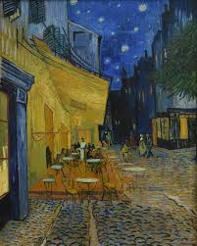
Café Terrace at Night

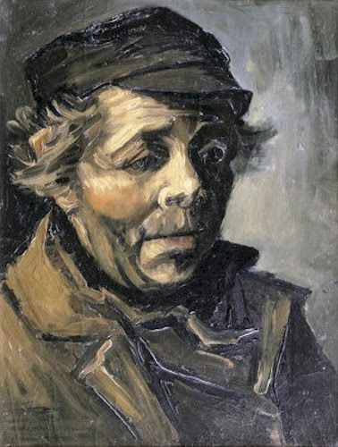
Head of a peasant

