My Vincent Van Gogh
Most people have heard Vincent Van Gogh’s name and have seen some of his most famous works of art. He is recognized as a Dutch painter who became one of the most famous artists in the history of art. But Van Gogh was more than that. Even though he was described as an unstable man with nervous temperament, he was also an emotional person longing for affection. A man who loved nature and felt compassion for the poor. He was definitely not an ordinary person
Vincent van Gogh was born in the Dutch village of Zundert, the eldest of seven children, the son of pastor Theodor van Gogh. Vincent was named after his grandfather, who had also given him the name of the firstborn child of the family, who had died in infancy. From a very young age, he showed signs of melancholy and early psychological problems. At the age of 16, and after having already tried several jobs without success, he worked for a while in the art trade at Goupilator & Company, where his brother Theo van Gogh was also hired the following year. In 1873, the company transferred him to London and later to Paris. During this period, his interest in religion intensified, clearly influenced by his father's status. After being fired from his job in 1876, he returned to Amsterdam to study theology. His studies lasted about a year and in 1878 he was assigned a position as a preacher in Belgium, specifically in the degraded Borinage region, where he operated a mine. Van Gogh preached for about six months, showing particular interest in the poverty of the people of the region. This is also the period in which he begins to design small works and probably decides to pursue art. In 1880, at the age of 27, he began taking his first painting lessons, but soon fell out with his teacher, Anton Mauve, over artistic issues. In the following years, he created works mainly influenced by the painting of Jean -François Millet, while he traveled to the Dutch countryside painting subjects inspired by it. In the winter of 1885 , he attended classes at the Antwerp Academy , which were soon interrupted after he was expelled by the academy's professor, Eugene Siberdt. Despite this, van Gogh managed to come into contact with Japanese art, from which he borrowed elements or often imitated its style. Several of his portraits also include a work of Japanese art in the background.
After staying in Paris he decided to move to Arles, and gaugin joined him. However, after a few months, the two had a heated argument and due to his unstable mental health, van Gogh cut off part of his left ear, ending up in a local hospital. There are allegations that van Gogh had threatened to kill Gauguin and proceeded to cut off his ear in search of a kind of catharsis from his remorse.
In 1889 he was admitted to the psychiatric center of the monastery of Saint Paul in Saint-Remy, where he remained for about a year, suffering from depression. During his stay there, he continued to paint. In May 1890, he left the psychiatric clinic and lived for a while in an area near Paris, where he was monitored by the doctor Paul Gachet, who had been introduced to van Gogh by the painter Camille Pissarro. During the time he was under medical supervision, van Gogh produced a single work, which was a portrait of Gachet. In July 1890, van Gogh began to show signs of severe depression and eventually shot himself in the stomach on July 27, dying two days later. Another theory is that he was shot by two teenagers. It is not entirely certain what his last work was, but it is likely to have been Daubigny's Garden or Cornfield with Crows. After van Gogh's death, his fame spread rapidly, culminating in major exhibitions of his works held in Paris, Amsterdam, Cologne, New York and Berlin. In total, he created more than 900 paintings and 1000 smaller drawings over a period of about ten years. His extensive correspondence with his brother, which includes more than 700 letters, still survives.
Last but not least Van Gogh was a sensitive and generous person who sought love, felt compassion for those who suffered. A person who liked to express his feelings through words as much as trough his art. His apparent love for nature can be seen not only in his paintings but also in his elaborate descriptions of the places he lived or visited. Vincent Van Gogh was an amazing personality.
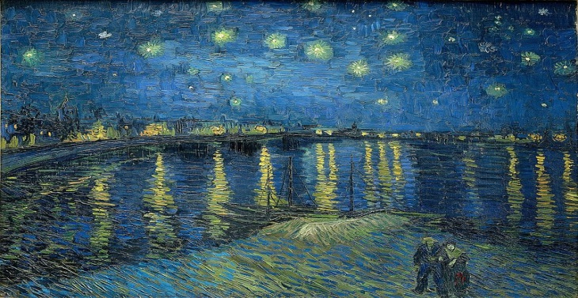 ΠΑΡΑ ΑΝΣΤΑΣΙΑ Α4

