Activity 1
Read the following texts and match the people 1-5 to a suitable holiday destination.
- Petra: My husband and I always like to go to places where we can enjoy the peace and quiet of the countryside. We don’t need luxurious accommodation but it is important that we can have easy access to it.
- John: Every year I enjoy spending my holidays climbing up the mountains. This year I’d rather go camping to a seaside fishing village.
- Peter and Maria: Our favourite destinations are historical places where we can visit ancient sites and museums.
- Karen: We are planning a school trip and we want to go somewhere where there is a lot of action and nightlife as well as some theatres and museums.
- Ted: We usually spend our holidays in all-inclusive hotels as our children are very young and they enjoy spending time in the pool. This year we are planning to surprise our kids by taking them to a famous amusement park in Europe.

- Eurodisney,Paris 2. A log cabin in the forest
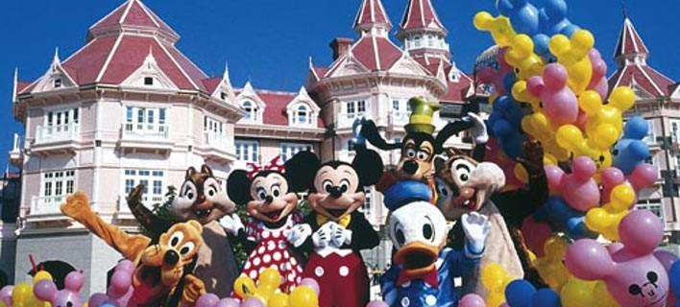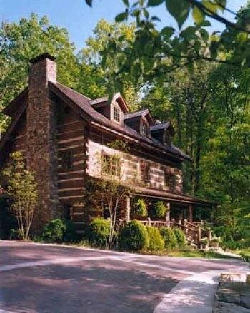

- Leros, a Greek island 4. Knossos,Crete
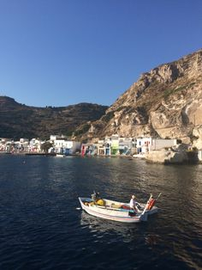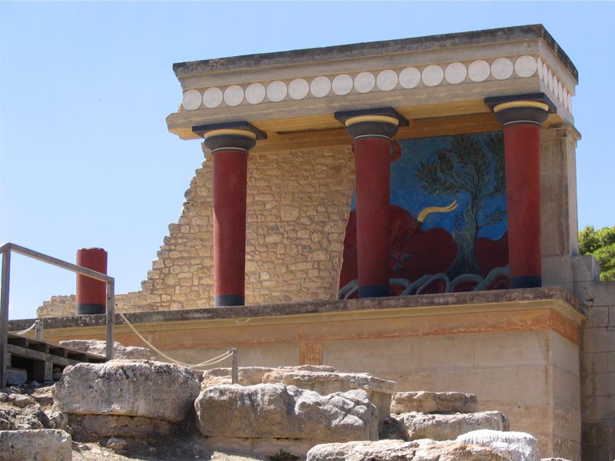

5.Louvre,Paris

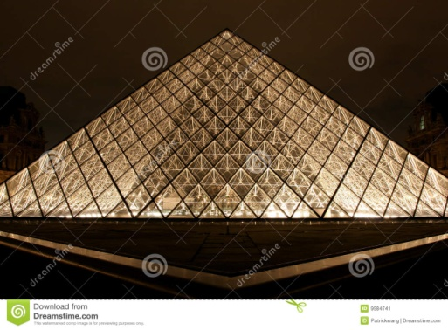
a……….. b……. c…….. d……. e…….
( 2 points )

TEXT B
Activity 2
Read the texts. Are the following sentences True or False according to the texts?
The Pyramids
The oldest wonder is the Great Pyramid of Cheops at Giza in
Egypt. It is the only surviving wonder. The monument was built
by the Egyptian pharaoh Khufu around the year 2560 BC.
Although scientists are still arguing about the main reason for
the pyramid, we know for certain that it was used as his tomb
when he died. Each side measures 229 metres long. It was
the tallest building in the world for more than 43 centuries.

The Statue of Zeus
The statue existed near the ancient town of Olympia. The Athenian sculptor Pheidias
began working on the statue around 440BC. The statue was 13 metres tall and sat on
a 6 metre wide base. The statue was so high that visitors could see it from as far as
five kilometres away. The Greek Pausanias wrote “On his head is a wreath of olives. In his right hand he holds a figure made of ivory and gold. His robe and sandals are made of gold, and his throne is decorated with precious stones, ebony and ivory”.

- These two of the seven Wonders of the World were in the same continent.(*continent= ήπειρος) ……..
- They were built at about the same time. …….
- The Pyramid was built as a tomb for the pharaoh. ….
- The statue of Zeus took Fheidias 13 years to finish it. ….
- The statue of Zeus was made of expensive material(*material=υλικά) ….

( 2 points )

