Transportation:
Airport:Skg,Greece
Airline:Edelweiss-Air
Destination:Paris
Beginning:9:00a.m
Arrival:13:00p.m
Return:1)Beginning:8:30a.m
2)Arrival:12:30a.m

Accomodation:Disneyland Hotel(Located:inside the park as you enter) 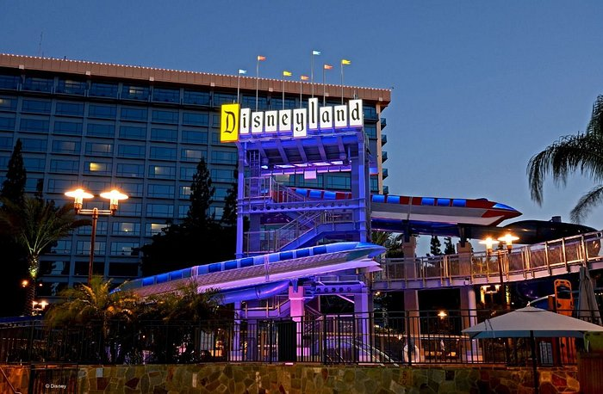
The reasons why we selected this hotel are: 1)it is located inside the park reducing the chances of a possible trasportation accident, 2)It offers Free breakfast and dinner to it’s luxury buffet, last but not least, 3)It is pretty chip for it’s conforts

Food:
All 5 days:Breakfast)9a.m at the buffet
Lunch:5/4 Pizza special
6/4 Pasta carbonara
7/4 Steak with French Fries
8/4 Snitchel with Fries
9/4 2 burgers with Fries and Sauce
10/4 Special Disney dish with boiled pork and smashed potatoes
Dinner:10p.m at the buffet

Morning Schedule:5/4 9:30a.m we are visiting 3-1.5hours rides and then a 1.5Hours movie
6/4 9:30a.m we are visiting a Disney early access preview for 5 new movies roughly estimated around 2 hours and then a free guide tour around the park with a guide which is going to long 4 hours
7/4 9:30a.m we are going to watch a mini tutorial about how does the production studios create the movies which is going to last 3.5 hours then it follows an exhibition with machines that are not being used to create movies anymore that has a duration of 2.5 hours
8/4 9:30a.m we are visiting 5 stores where students can buy accessories and gifts.Then we are heading for lucnh as soon as students finish their shoppings
9/4 9:30a.m Students will have the whole day free to savor the park and attend whatever activity they like
10/4 9:30a.m There will be a goodbye event especially organized for the school trip that starts at 7a.m and ends in 8a.m

Afternoon Schedule:For The whole trip students will have freedom to do everything in the park

Total Costs:Transportation:Plane Tickets:262x15=3930
Accomodation:95x5x15=7,125

