Α. Reading Comprehension
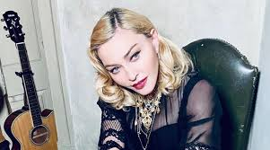
A. Madonna
Madonna has never been shy about standing up for what she believes in. She supports Children of Peace, which works to protect children from the violence in Israel and Palestine, and she helped to start the charity Raising Malawi- which focuses on trying to help Malawi’s orphans. A spokesman for the Malawian government reported: “ Madonna has managed to put their terrible situation on the world stage. She has been to several areas where the government has failed to reach and has helped to build hospitals that have saved many lives”. The singer has also adopted two little orphans from Malawi.

B. Angelina Jolie
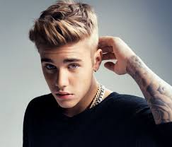
A trip to Cambodia to shoot the adventure film “ Lara Croft” was what first opened Angelina’s eyes to the poverty there, but it was her admirable work with the United Nations that opened the eyes of the rest of the world. Back home, she has adopted three orphan children and this has encouraged several other celebrities to do the same.
C. Justin Bieber
Bieber supports Pencils of promise, a charity whose aim is to build schools in developing countries, and he became manager for the organisation’s campaign in Guatemala. He has helped this charity by advertising its campaign “ Schools4All”, and promising to visit the schools that give the most money to this cause. He has also taken part in fund-raising events and put on concerts for the charity. Bieber also supports PETA, an animal charity, and encourages people to volunteer at and adopt from animal shelters instead of buying pets at pet stores. Bieber himself adopted a little dog named Sammy from a shelter.
Question 1.
Who ….
- supports a charity to help children’s education? ………..
- learned about poverty while filming? …………
- achieved better results than a government? …………
- made other famous people follow his/her example? ………
- has used his talent to support a charity? ……….
Question 2.
Are the following sentences True or False?
- Madonna supports two charity organizations in Israel. ……
- Two of these celebrities have adopted children from a country where they have organized a charity. ….
- Madonna starred in “Lara Croft” . ….
- Angelina Jolie is a singer. ……
- Justin Bieber supports an organization which is about animal protection. …….

