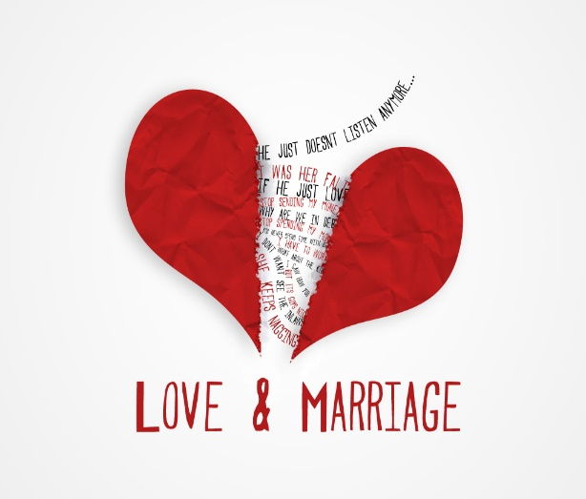
Worksheet
1.
- Think about the question: "What makes a good marriage today? What do you think made a good marriage in the past?" Note down 3-4 words that come to your mind
- Pair with your partner: Discuss your ideas and compare your words
- Share your ideas with others: Share your thoughts in class

2.Match the words with their definitions in the following quiz. Which words do you think were more important for marriage in the past? What about today?
3.You are going to watch a short video of Mr. Darcy’s first proposal to Elizabeth. While watching the video keep notes on the following:
- Darcy’s reasons for marriage.
- Elizabeth’s reaction.
- The emotions of both characters.
4.In groups answer the following questions:
- Why does Darcy propose?
- Why does Elizabeth refuse?
- Would this proposal work today? Why or why not?
5.Write a short note/memo from either Elizabeth or Mr. Darcy, giving reasons for your decision after the proposal. Exchange your notes with your partner and underline any strong emotions
6.Exit cards. Complete one of these statements with your response.
- "One thing that surprised me about marriage in Pride and Prejudice is……………………………………………………………………………"
- "Today, marriage is different from the past because…………………………………………………………………"
- "If I lived in the 19th century, I would/wouldn’t marry for love because …………………………………………………………………"

Home assignment
Watch the scene where Monika proposes to Chandler in the popular TV show Friends and compare it with Darcy’s proposal in Pride and Prejudice in a short paragraph (80-100 words). Upload your answer on our class’s eclass.

