Forming adverbs from adjectives
In most cases, an adverb is formed by adding -ly to an adjective.
Adjective | Adverb
cheap | cheaply
quick | quickly
slow | slowly

If the adjective ends in -y, we replace the “y” with “i” and add -ly.
Adjective | Adverb
easy | easily
angry | angrily
happy | happily
lucky | luckily

If the adjective ends in –able, -ible or –le, we replace the “e” with “y”.
Adjective | Adverb
probable | probably
terrible | terribly
gentle | gently

If the adjective ends in -ic, we add -ally.
Exception: public -> publicly
Adjective | Adverb
basic | basically
tragic | tragically
economic | economically

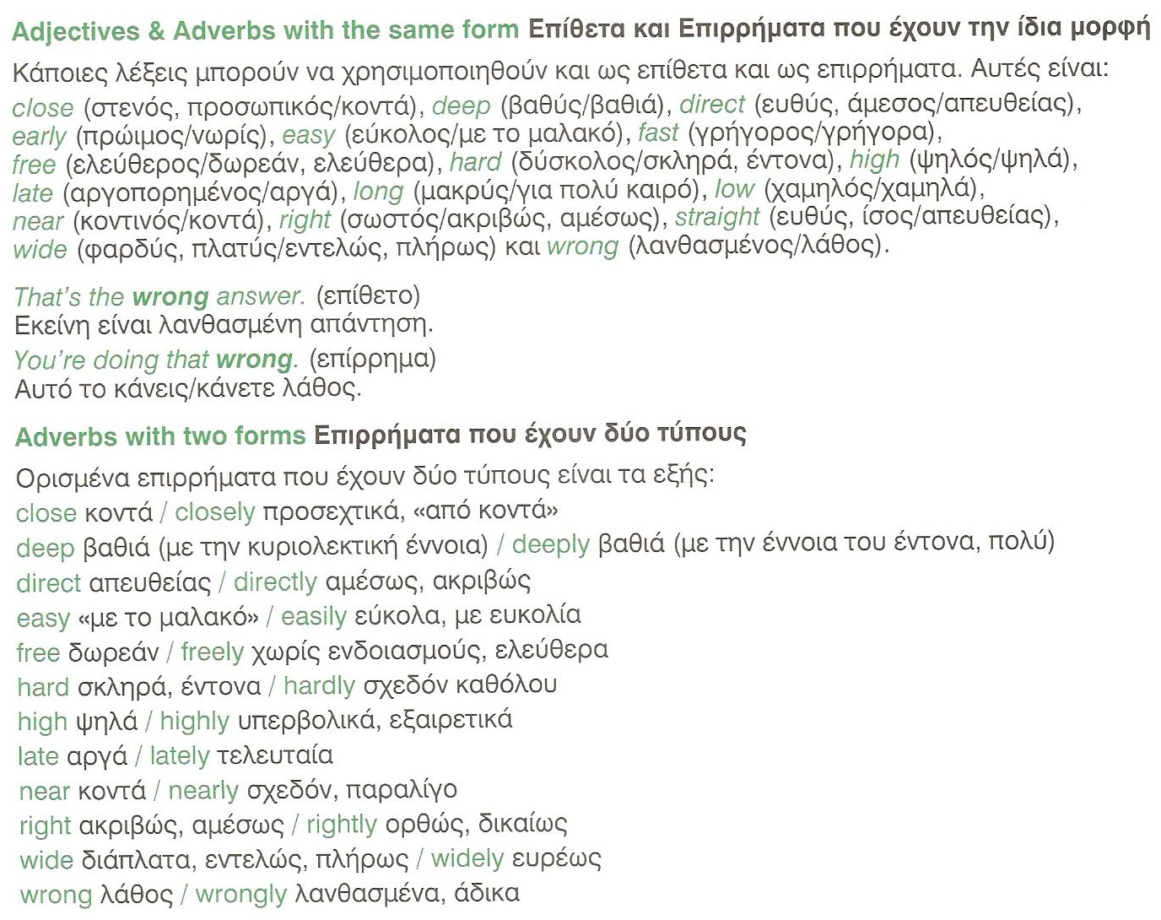

Examples
- I slept late again, so I’m going to get in trouble with my teacher.
- I’ve been worried about my future lately.
- You’ll have to work hard if you want to impress your boss.
- I hardly got any work done with all the noise.
- Hardly anyone showed up for my party.
- Don’t drive so close to the car in front of you.
- They are closely related.
- She worked closely with me on the project.

