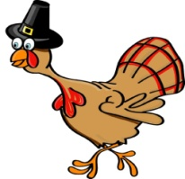
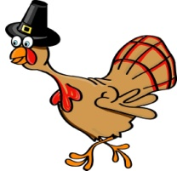
Thanksgiving History Facts
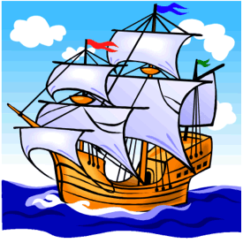
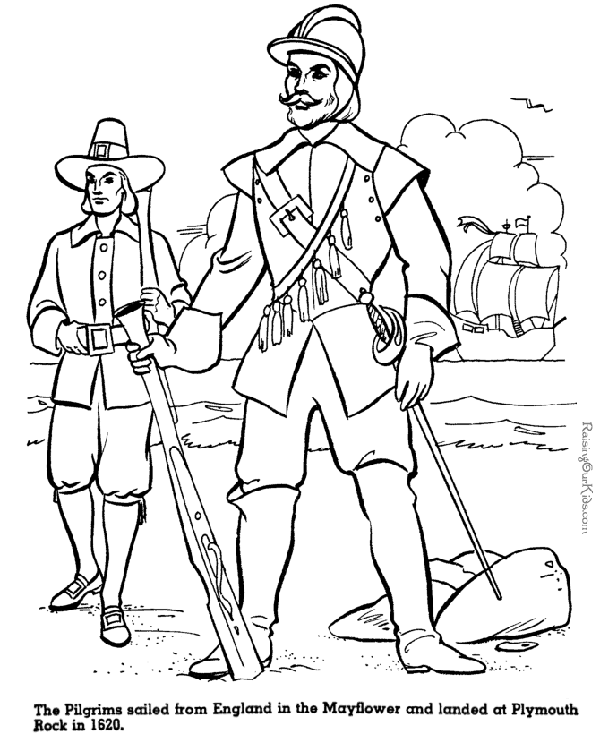
A ship, called “Mayflower”, took off at September 6th 1620, with 102 people (the pilgrim) and 30 crew members on board to the new world of America, later called “New England”.

The pilgrim had been traveling for 65 days until they reached the new world on November 11th in 1620.
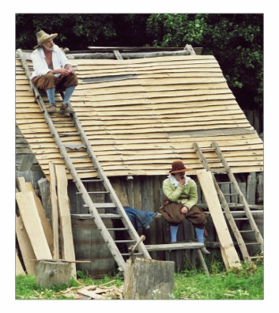
While the men were building houses for the small village of Plimoth, the women and children had to stay on board of the Mayflower for another 2 months. In this winter more than 50 people died because of illness and coldness.
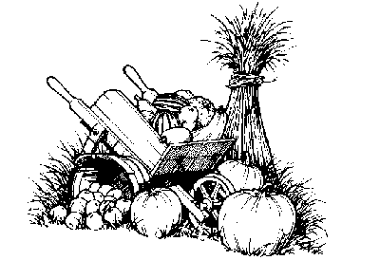
In January 1621, the pilgrim had the first contact to the “Wampanoag”, a tribe of Native Americans. They taught the pilgrim how to hunt and how to plant or grow up corn and other plants.

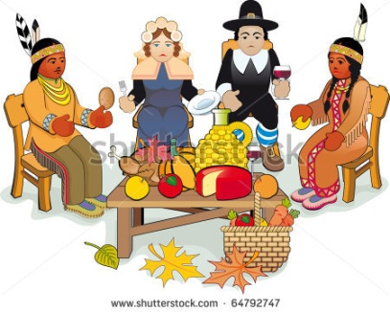
In autumn 1621, when the pilgrim had enough food, they wanted to thank the Wampanoag for their help and celebrated the first American Thanksgiving, the “Harvest Feast”. They celebrated it for almost 3 days and nights.
Thanksgiving History Facts
A ship, called “_________”, took off at September 6th 1620, with 102 people (the pilgrim) and 30 crew members on board to the new world of America, later called “___________”.

The _______ had been traveling for 65 days until they reached the new world on November 11th in 1620.
While the men were building houses for the small village of_______, the women and children had to stay on board of the Mayflower for another 2 months. In this ______ more than 50 people died because of illness and coldness.
In January 1621, the pilgrim had the first contact to the “_________”, a tribe of Native Americans. They taught the pilgrim how to hunt and how to plant or grow up corn and other plants.

In ___________, when the pilgrim had enough food, they wanted to thank the Wampanoag for their help and celebrated the first American Thanksgiving, the “_____________”. They celebrated it for almost 3 days and nights.

