2nd sensor type
Ok, let’s see how to use another type of IR sensor with Arduino.
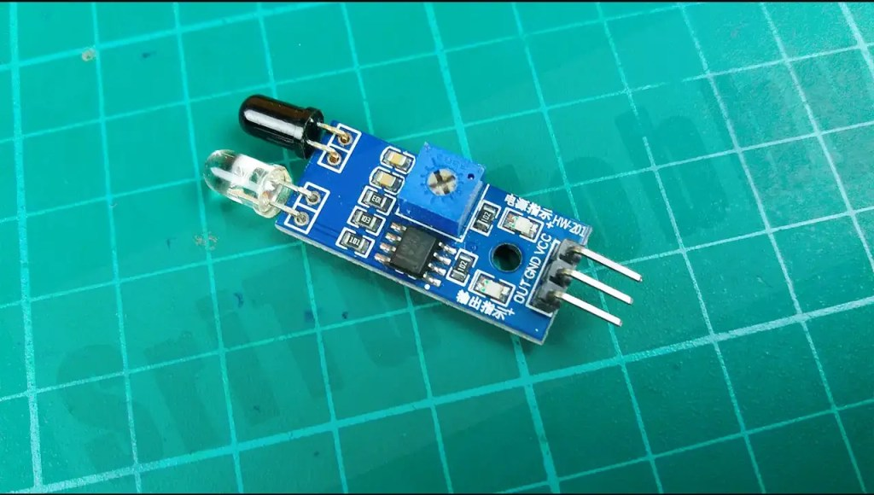

The PIN structure of this sensor
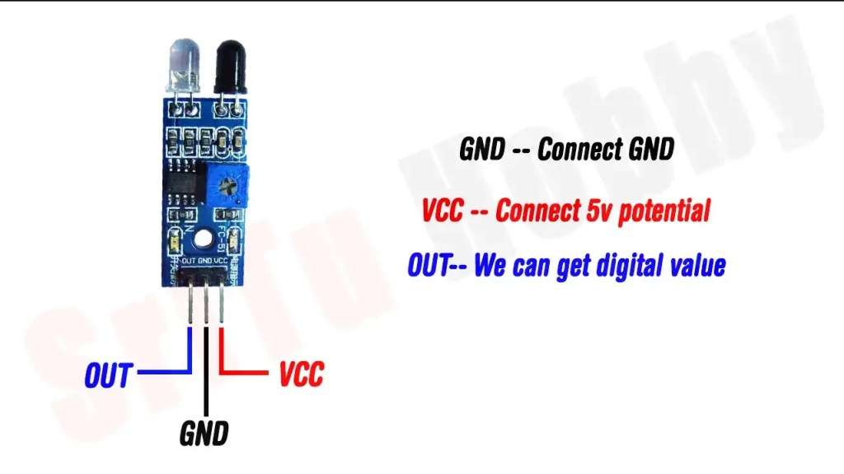
So, step by step we will learn how to connect this sensor with Arduino. For that, the required components are given below.
- Arduino Nano board — Our store / Amazon
- IR sensor — Our store / Amazon
- LED bulb — Our store / Amazon

Step 1
Firstly, identify these components.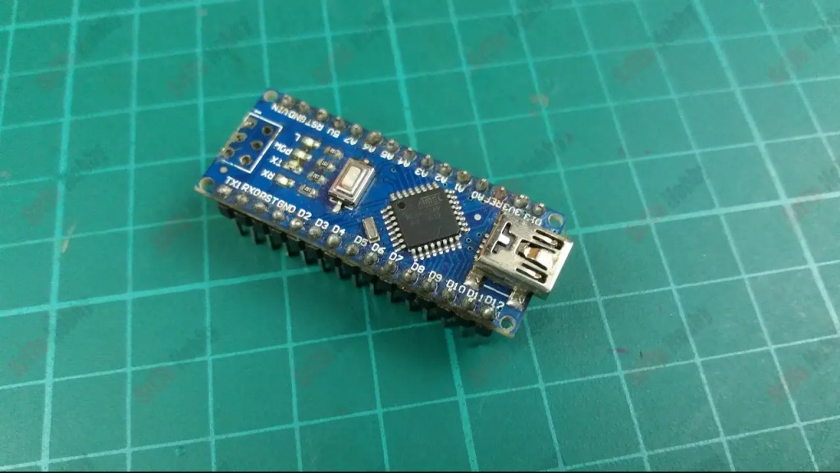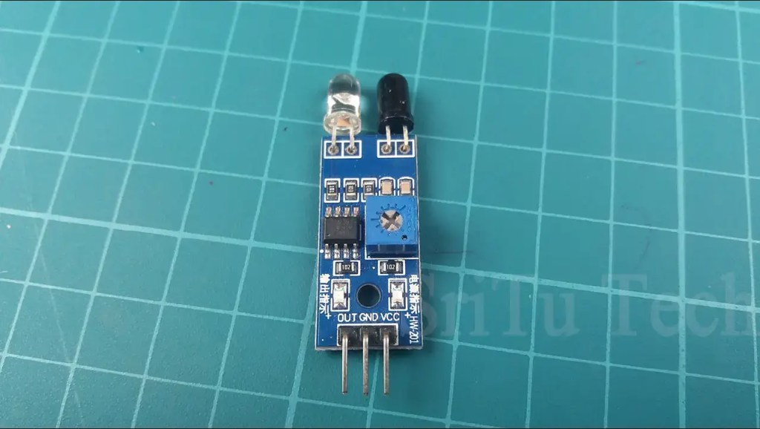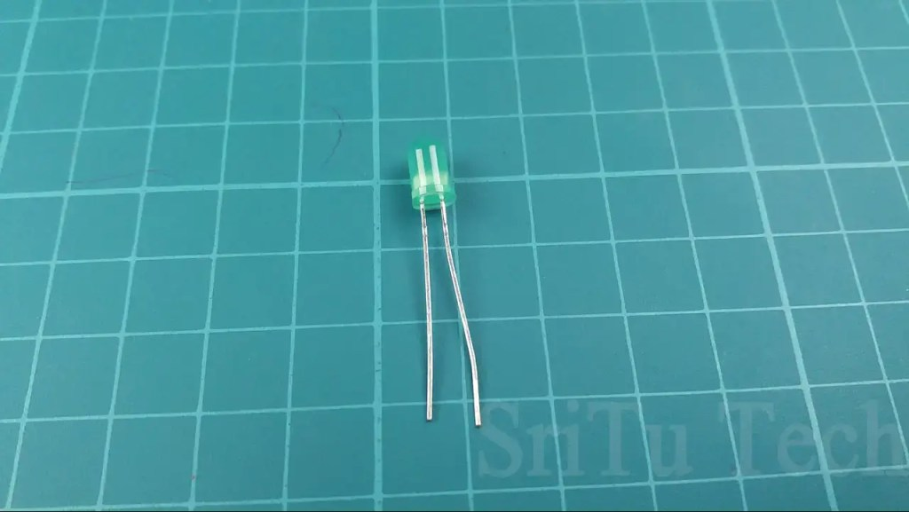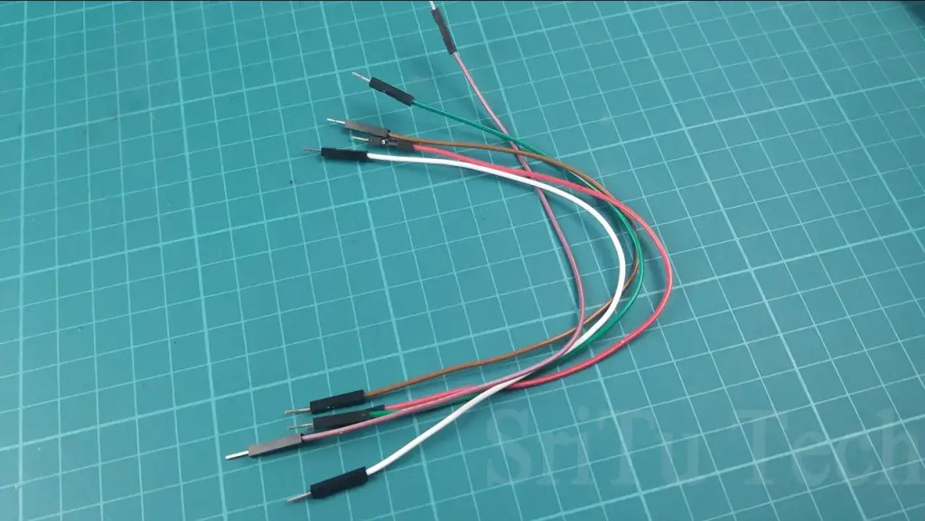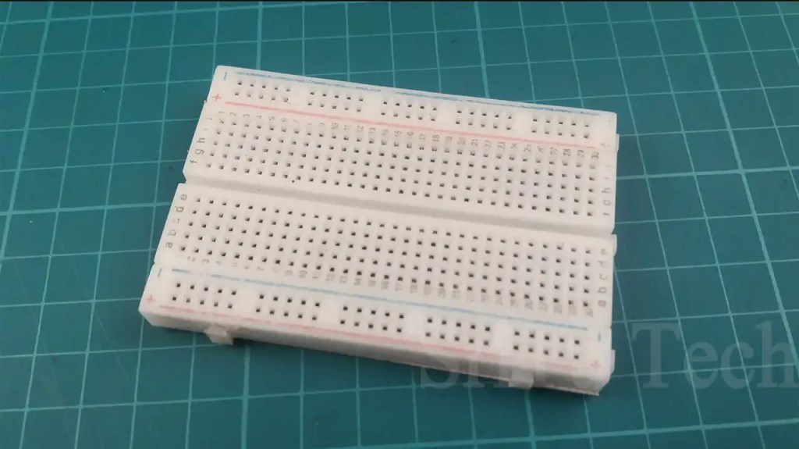

Step 2
Attach the components to your breadboard.
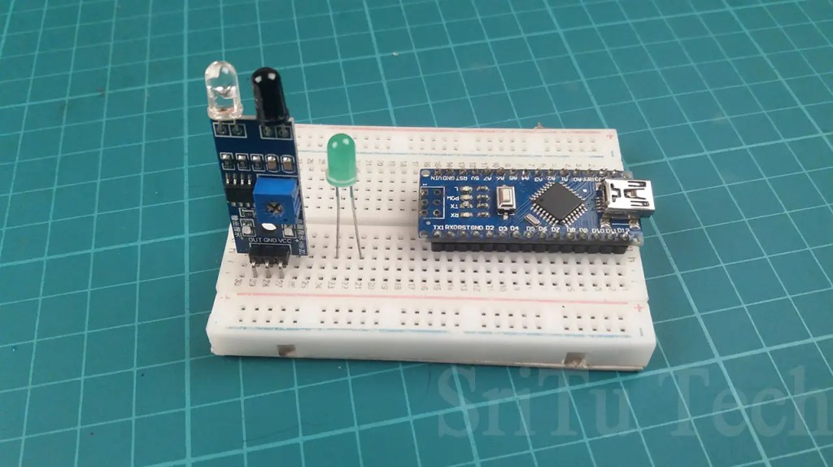

Step 3
Connect these components to your Arduino board using the jumper wires. Do it according to the circuit diagram below.
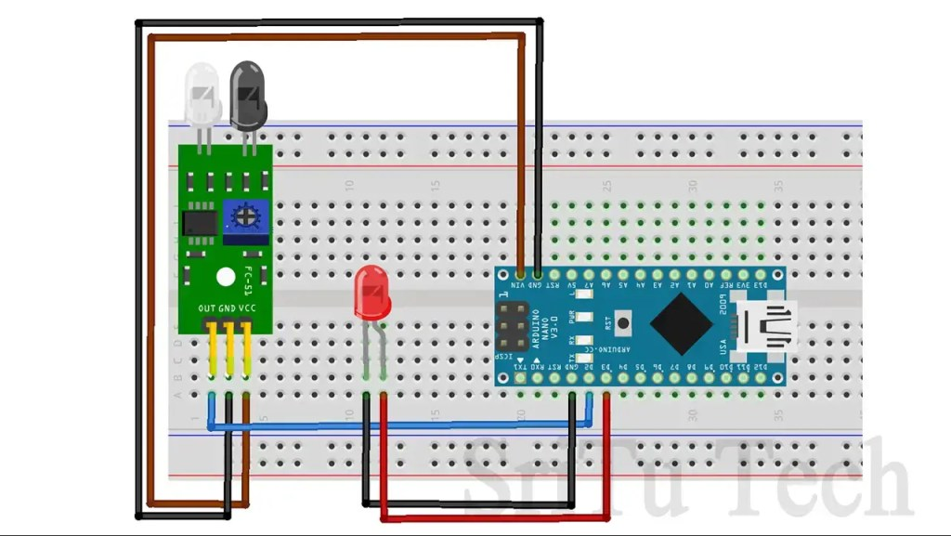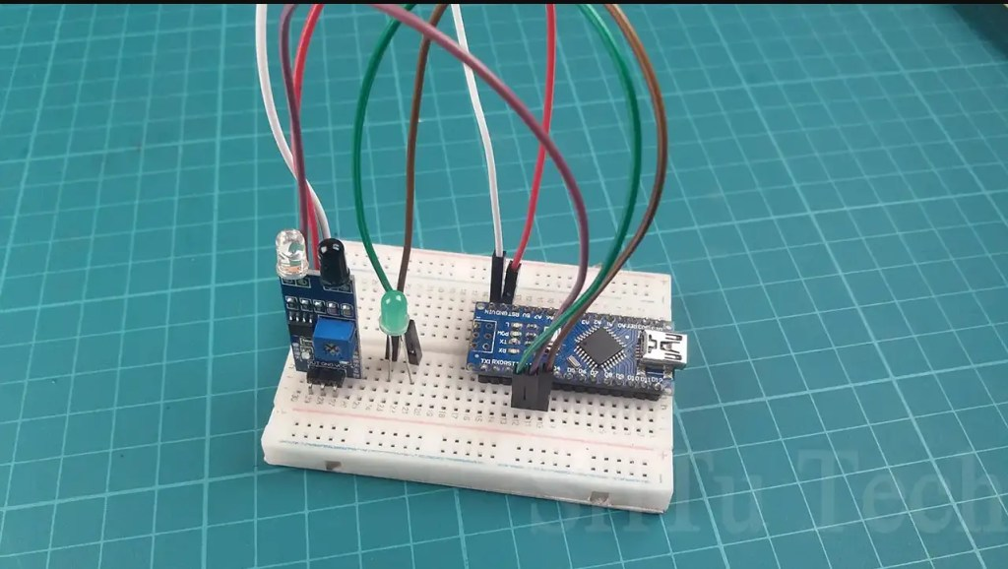
Connect the sensor OUT pin to the Arduino board D2 pin and connect the LED anode pin to the D3 pin.

Step 4
Now, copy and paste the following program to the Arduino IDE.
- The complete program of this project – Download

void setup() {
pinMode(2, INPUT);//define arduino pin
pinMode(3, OUTPUT);//define arduino pin
Serial.begin(9600);//enable serial monitor
}
void loop() {
bool value = digitalRead(2);//get value and save it boolean veriable
if (value == 1) { //check condition
Serial.println("ON");//print serial monitor ON
digitalWrite(3,HIGH);//LED on
} else {
Serial.println("OFF");//print serial monitor OFF
digitalWrite(3,LOW);//LED off
}
}
This code sets 2 pins as input pins and 3 pins as output pins.
void setup() {
pinMode(2, INPUT);//define arduino pin
pinMode(3, OUTPUT);//define arduino pin
Serial.begin(9600);//enable serial monitor
}
Takes the digital value and puts it into the Boolean variable. The Boolean variable is named ‘value’.
bool value = digitalRead(2);//get value and save it boolean veriable
This value is checked using the IF condition. When the digital value is 1, the LED bulb turns on and when the digital value is 0, the LED bulb turns off.
if (value == 1) { //check condition
Serial.println("ON");//print serial monitor ON
digitalWrite(3,HIGH);//LED on
} else {
Serial.println("OFF");//print serial monitor OFF
digitalWrite(3,LOW);//LED off
}

Step 5
Now, select the board and port. After, click the upload button.
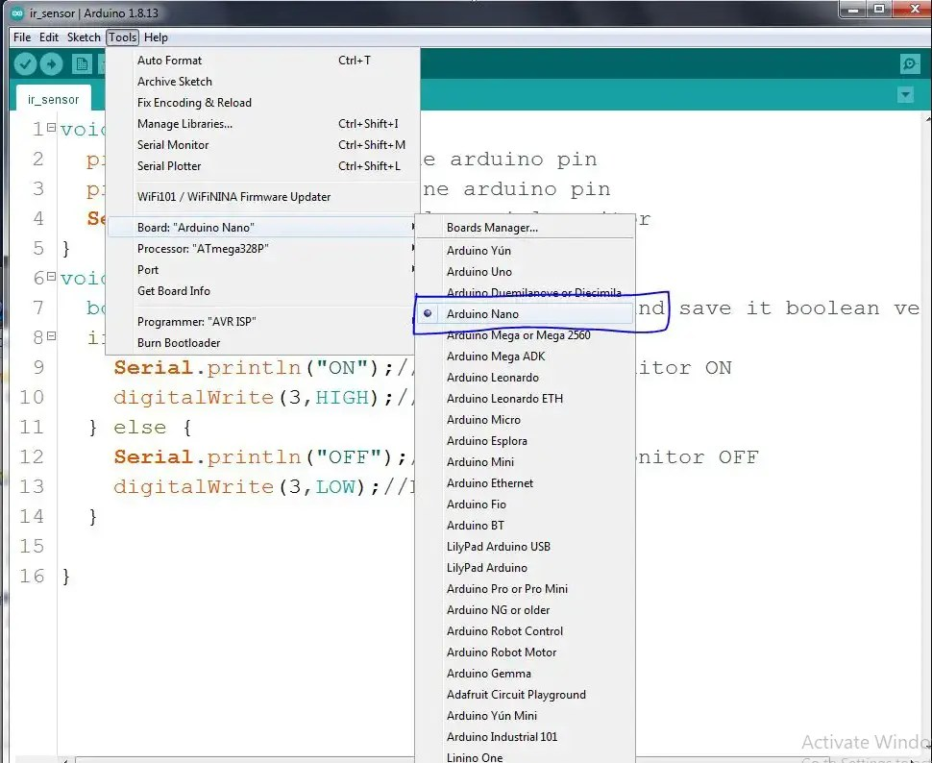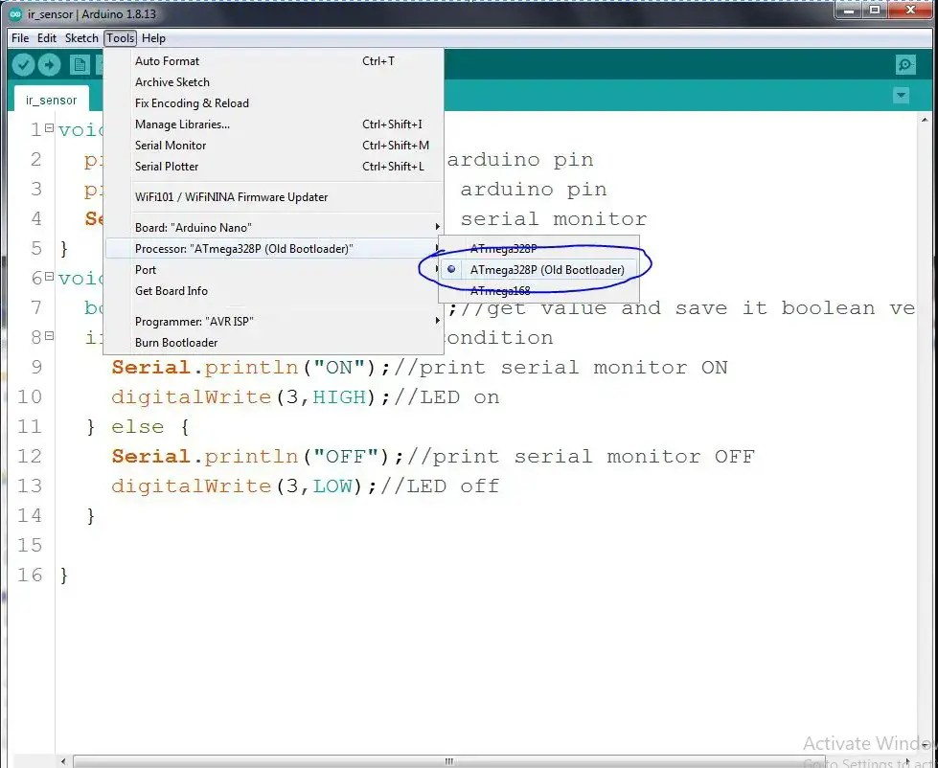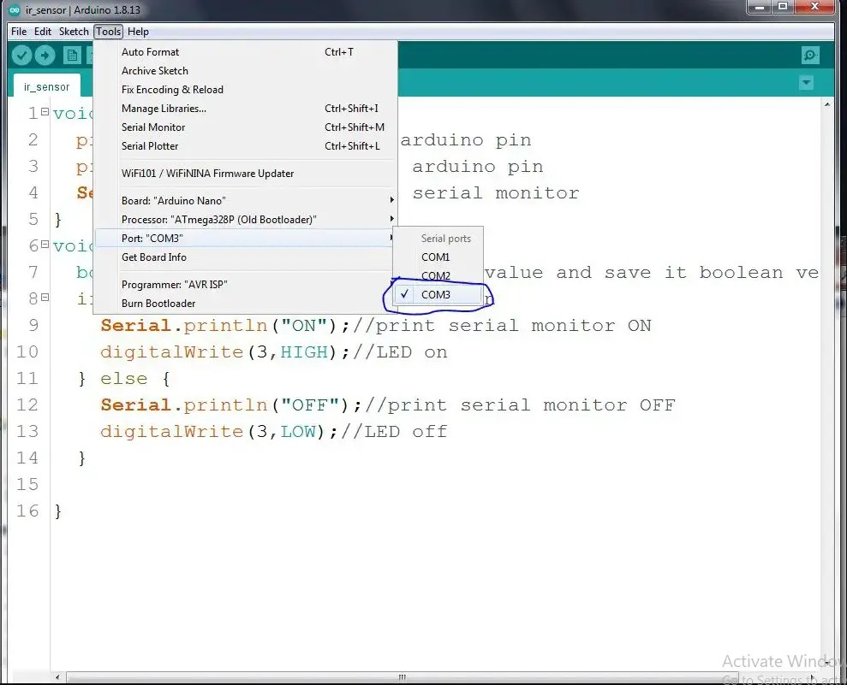
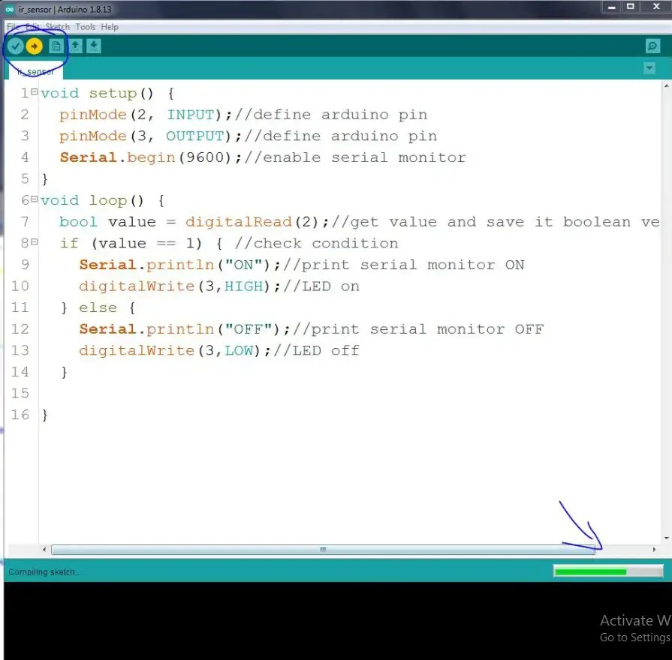
So, now you can test this sensor. The full video guide is given below.
IR infrared sensor with Arduino – How does work IR infrared sensor

