Θέμα: Περιβάλλον

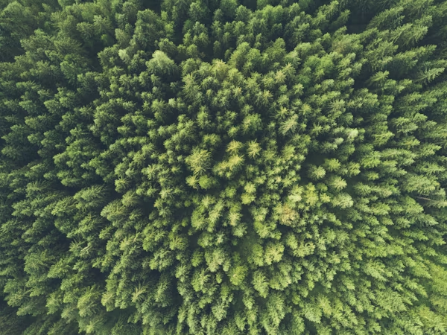

John O Nolan, Unsplash,
https://unsplash.com/photos/bird-eye-view-photography-of-a-green-trees-uMWPrcRsrto

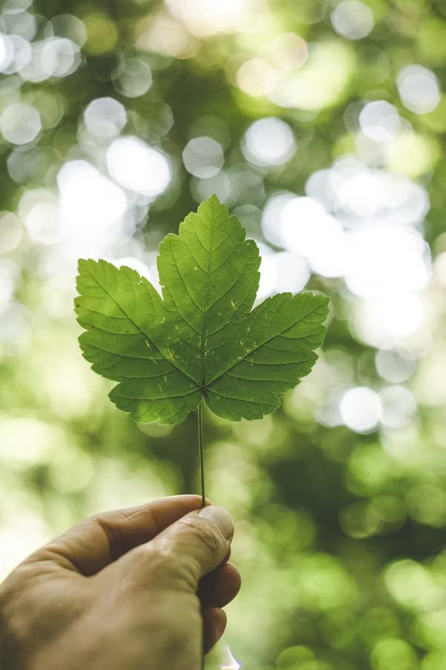

Markus Spiske, Unsplash,
https://unsplash.com/photos/person-holding-green-leafed-plant-GnxktpZHjcM

