MAY DAY!!
May day is a holiday celebrated on the firs day of May in different parts of the world for two reasons.
First, it a celebration of new life and the beginning of Spring. The month itself is named after the ancient Roman Goddess Maia or Maja that means large or important. May Day celebrations have their roots in festivals such as the Greek Maiouma and the Roman Floralia. They included dancing, singing, eating and drinking, as well as competitive events and spectacles. Maypole dancing, a tradition in the UK since the medieval times, is still popular today. It is known n Greece as the “gaitanaki”. Children dance around a pole and holding each a ribbon. They try to form shapes by folding the ribbon around the pole. Children very often sing along while they are dancing.
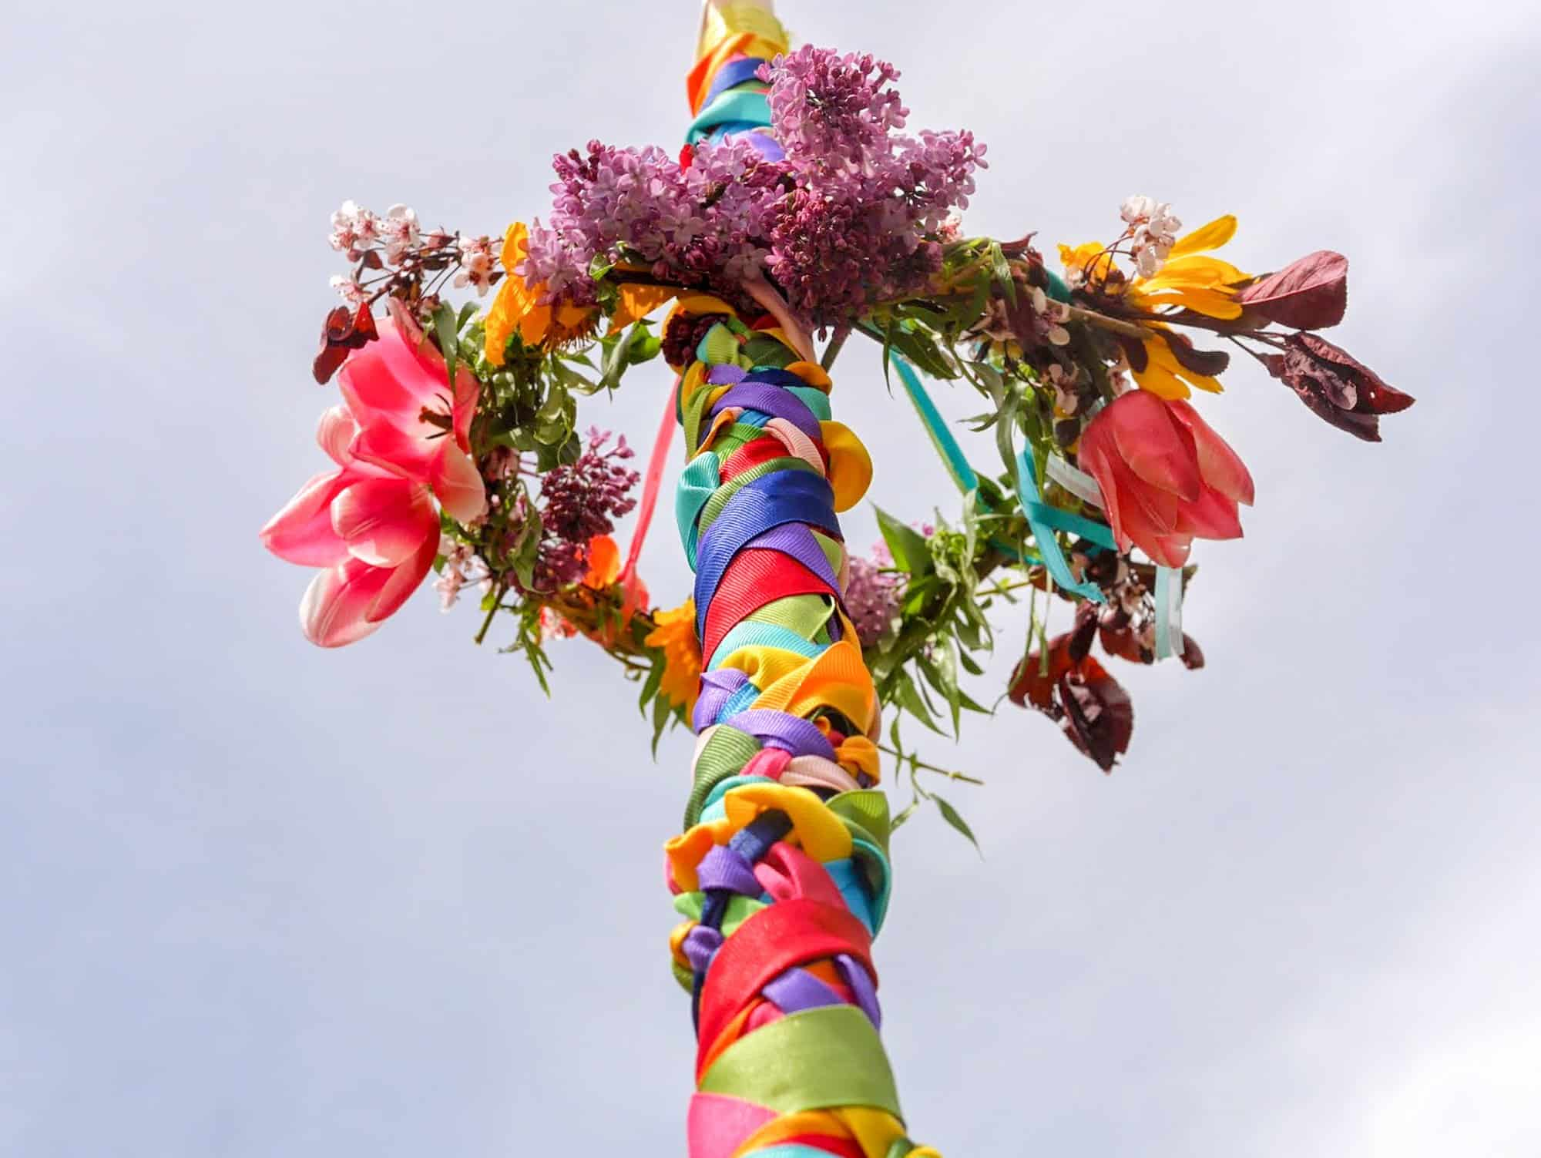
Another UK tradition is that of the Morris dance. Dancers wear colourful clothes and hold sticks to perform this folk dance. Sometimes they paint their faces black. This tradition dates back to the old times when people asked for money for the dance and they didn’t want to be recognized. The Morris dance is very popular in the UK and many dance groups take part in competitions around the country.
May Day is also celebrated around the world as workers’ day. In the 19th century, workers around the world fought for the right to work 8 hours shifts, for better pay and for better and safer working conditions. May the first is the day to celebrate and honour their struggles. May Day is also called Labour Day for this reason. Workers have the day off and celebrate with their families.

