Read to fill in before you listen to the song!
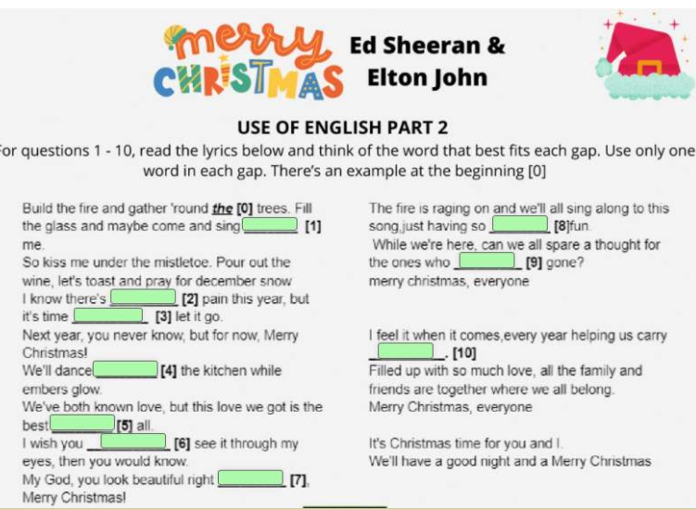
Listen to the song and check your answers!
The song: https://youtu.be/Q_yuO8UNGmY
Watch and answer:
How many sunglasses appear in the video?

