ΘΕΜΑ 1. ΚΑΤΑΝΟΗΣΗ ΓΡΑΠΤΟΥ ΛΟΓΟΥ (14907)
Read the text and decide if each statement (1-10) is True (A), False (B) or Not Mentioned (C).
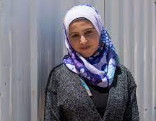
Muzon, a passionate supporter of girls and young women’s access to education in Jordan’s refugee camps, has been regarded as Syria’s answer to Malala. When Muzon’s family escaped the war in Syria in 2013, they briefly considered leaving her behind. The bright 14-year-old had been studying hard all year for her grade-nine school exams, which were just a month away, and her aunt encouraged the family to let her stay and continue her education.
However, her father decided that the risks were too great and that Muzon could make up for lost schooling, but if she lost her life there would be no way to make up for that. So the girl fled with him and her siblings to Jordan’s Azraq refugee camp. Education has always played a big part in Muzon’s life. Both of her parents were teachers back in Syria’s southern area of Dara’a, and her aunt and uncle were head teachers at local schools. “I didn’t need them to tell me that education is important. I always just felt it.” she explains. “Our house was built by an engineer. When I was sick I went to a doctor. Education is everything in life.”
Now 17, not only has she continued her studies in Jordan, but she has become a powerful and high-profile supporter of education among Syrian refugees, especially young women and girls. Her campaigning shares a number of similarities to that of Malala, Pakistan’s Nobel Prize-winning education campaigner, whom Muzon considers a personal friend. “She taught me that no matter what obstacles I face in life, they can be overcome.” The family’s main home in Izra was close to a military base that regularly came under attack. Unable to tolerate the fighting any longer, they made their way to Jordan and settled in Za’atari refugee camp.
(Words: 300)

Statements |  | A | B | C
 |  | TRUE | FALSE | NOT MENTIONED
 | Muzon is a teacher who helps young refugee girls pass their school exams.
 | Muzon’s family had to leave Syria because of the war.
 | The family left Muzon behind to live with her aunt in order to continue her education.
 | Muzon’s family refused to settle in a refugee camp.
 | Muzon’s parents built their house in Izra with the help of a professional.
 | Muzon wants to pass her university entrance exams in order to study medicine.
 | Muzon was forced to drop schooling when she settled in Jordan.
 | Both Muzon and Malala have won a Nobel Price for their education campaign.
 | Muzon has realised that there is no difficulty that cannot be overcome.
 | The family decided to leave Syria in order to build a bigger house.

ΘΕΜΑ 2^{α}. ΛΕΞΙΚΟΓΡΑΜΜΑΤΙΚΗ

Use the correct form of the following words (A-K) to complete the gaps (11-20) as in the example.
A. | decide | B. | consider | C. | risk | D. | encourage | E. | passionate | F. | supporter
G. | friend | H. | education | I. | answer | J. | base | K. | able

EXAMPLE | When you have a strong FRIENDSHIP with someone, you feel you can tell him/her anything and you love to spend time with him/her.
 | Bill thanked all his colleagues for their _________ messages and wishes for speedy recovery while he was in hospital.
 | After careful _________, we decided to offer her the job. She couldn’t believe her ears when she was told the good news.
 | All students loved attending her classes because she had the_________ to explain things clearly by using everyday examples.
 | Even when I am not sure about the answer to a question, I try to leave no questions _________ in a school exam.
 | ‘I could never have achieved this without the _________ of my husband and family. They always believed in me and stood by me.’ Mary admitted.
 | The adventure film included a number of _________ scenes but the actor was well trained and not afraid of doing all the dangerous stunts by himself.
 | You don’t want to make the wrong _________ and regret it later. In order to choose the right career, you must first think of your values, interests and skills in combination with your personality type.
 | Their _________ problem is that they don't talk to each other. They don’t seem to realise that the way we communicate or connect with others can have a major impact on our lives, not only in couple relationships but in all our other relationships too.
 | All _________ in our school are well trained and experienced. The students get on really well with them and enjoy every single minute of the classes.
 | The activists fought _________ for their cause; there was nothing that could stop me from protecting the community park in their area.

37638
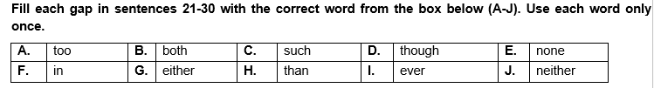
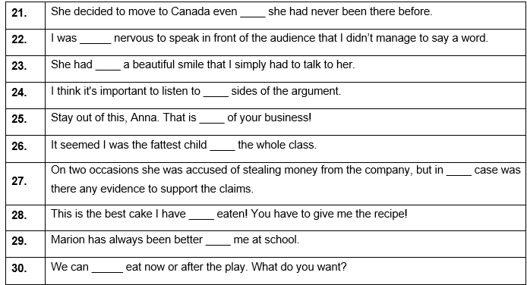
37651
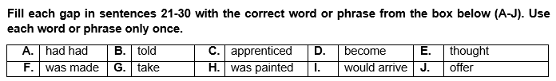
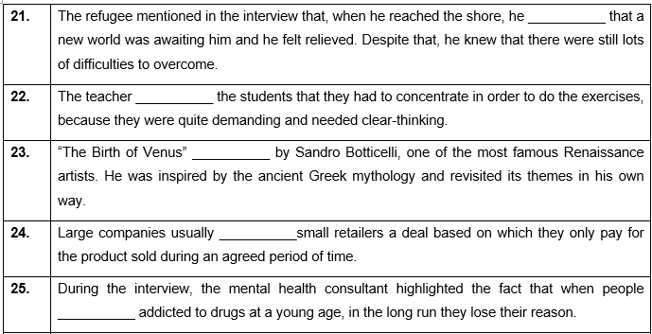
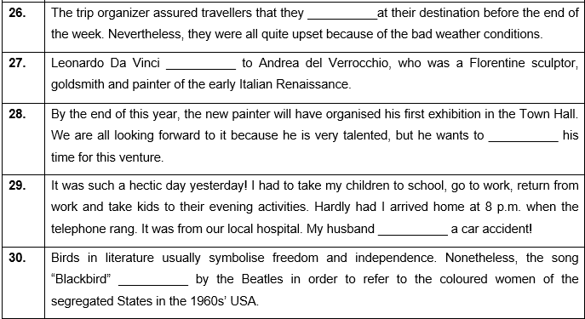
37645
