ΘΕΜΑ 1. ΚΑΤΑΝΟΗΣΗ ΓΡΑΠΤΟΥ ΛΟΓΟΥ (3900)
Read the text and decide if each statement (1-10) is True (A), False (B) or Not Mentioned (C).
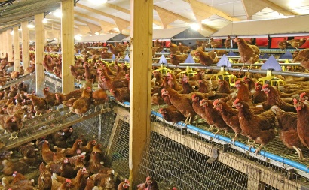
Taking a closer look at animals raised in factory farms, we come to understand that farm animals need our help.
But what is a factory farm? A factory farm is a large industrial operation that raises large numbers of animals for food focusing on profit and efficiency while causing harm to their welfare. It is a fact that over 99% of farm animals in the United States are raised in factory farms.
Approximately 8.5 billion chickens are killed for their meat every year in the U.S., while another 300 million chickens are used in egg production. All birds, from egg-laying hens and meat chickens to turkeys, ducks and geese are kept out from all animal protection laws. Therefore, these animals are in urgent need of protection. The American Society for the Prevention of Cruelty to Animals (ASPCA) is focused on making people aware of the unpleasant state of chickens raised for meat and is working actively with companies that buy or raise chickens.
Many people do not realize that the breed of chicken used for modern egg production is different from the breed used for meat production. If you put the two breeds of chicken next to each other, they look almost nothing alike! Each has been raised according to a plan for hyperproduction: egg-laying hens for high egg volume, and “meat” chickens for maximum breast meat. Unfortunately, both chicken types suffer from severe physical problems brought on by genetic control of their cells.
(Words: 244)

Statements |  | A | B | C
 |  | TRUE | FALSE | NOT MENTIONED
 | Farm animals live happily in factory farms.
 | Factory farms are industries that raise animals for profit.
 | Animal welfare is of great importance to factory farm owners.
 | 300 million chickens are killed for their meat in the U.S. every year.
 | Around 8.5 billion chickens produce eggs in U.S. factory farms every year.
 | Farm animals should be raised in open farms.
 | ASPCA tries to inform people about the conditions in factory farms.
 | Chickens raised in factory farms live no more than 5 months.
 | Chickens raised for egg production look the same as chickens raised for meat production.
 | Genetic cell control causes serious health problems to chickens in factory farms.

ΘΕΜΑ 2^{α}. ΛΕΞΙΚΟΓΡΑΜΜΑΤΙΚΗ
Fill each gap in sentences 11-20 with the correct word from the box below (A-J). Use each option only once.
A. | actively | B. | approximately | C. | maximum | D. | aware | E. | raised
F. | production | G. | profit | H. | farm | I. | urgent | J. | realized

Working on a ____ is really hard but satisfying at the same time; when my horses, chickens and cows look so happy and healthy I feel that all my efforts are worthwhile.
She makes a huge ____ from selling waste material to recycling companies.
Her husband died in a car accident so she ____ her children on her own.
Can you tell your mum it is really ____ to call me back as soon as possible?
He is very ____involved in environmental issues although he is the youngest member of Greenpeace.
As she was watching her favourite TV show, she suddenly ____ that the food was burning!
The meeting lasted ____ 4 hours but then we had to vote for the new president of our organization.
I am well ____ of my strengths and weaknesses; no need to remind me of my mistakes every day.
We watched a very interesting video showing the various stages in the ____ of glass.
Our school has a ____ of 27 students per class, which is the average class size in high schools.

Fill each gap in sentences 11-20 with the correct word from the box below (A-J). Use each option only once. (3898)
