ΘΕΜΑ 1. ΚΑΤΑΝΟΗΣΗ ΓΡΑΠΤΟΥ ΛΟΓΟΥ (12806)
Read the text and decide if each statement (1-10) is True (A), False (B) or Not Mentioned (C).

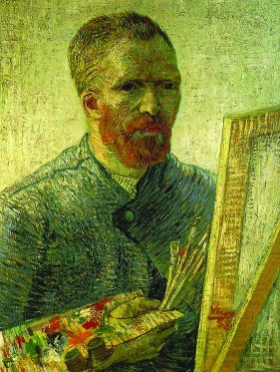
Vincent van Gogh was born in Zundert, Holland. His father was a pastor, so he was brought up in a religious and cultured atmosphere. Vincent found his father’s profession appealing and he was drawn to it, to a certain extent, later in his life. His sister described him as a serious and introspective child, highly emotional, without self-confidence. At age 16, Vincent started to work for an art dealer in The Hague. His four years younger brother Theo, with whom Vincent had a life-long friendship, would join the company later. This friendship is recorded thoroughly in a vast amount of letters they sent to each other. These letters contain a lot of information about the life of the painter and show him to be a talented writer with a keen mind. Theo would support Vincent financially throughout his life.
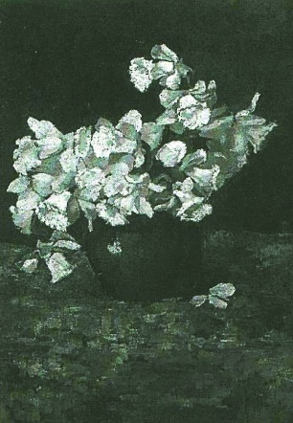
In 1880, Vincent van Gogh followed his brother’s suggestion and took up painting seriously. For a brief period, Vincent took painting lessons from Anton Mauve in Hague. Although Vincent and Anton soon stopped working together because of their different artistic views, influences of the Hague School of painting would remain in Vincent’s work, especially in the way he played with light and in the looseness of his brush strokes. However, his use of colours, favouring dark tones, set him apart from his teacher. In spring 1886, Vincent van Gogh went to Paris, where he moved in with his brother Theo; they shared a house in Montmartre.
(Extract: 245 words)

Statements |  | A | B | C
 |  | TRUE | FALSE | NOT MENTIONED
 | Van Gogh was Dutch.
 | Van Gogh’s family was not very religious.
 | Van Gogh is described as confident of himself.
 | The van Gogh brothers worked for the same company.
 | Theo paid van Gogh’s expenses for many years.
 | Theo advised van Gogh to become a professional painter.
 | Van Gogh stopped working with Anton Mauve because they did not agree on matters of art.
 | Van Gogh used only bright colours in his paintings.
 | Van Gogh preferred painting landscapes.
 | The two brothers lived together in a house in Paris.

ΘΕΜΑ 2^{α}. ΛΕΞΙΚΟΓΡΑΜΜΑΤΙΚΗ
Match each underlined word/phrase in the sentences below (11-20) with a word/phrase from the box that has a similar meaning (A-J). Use each word/phrase only once.
A. | brought up | B. | appealing | C. | extent | D. | serious | E. | provide
F. | support | G. | remain | H. | moved | I. | brief | J. | vast

Only a few hundreds of this animal species exist today.
Joan started living in an apartment when she started University.
The teachers had a short meeting before announcing their decisions to the students.
To what degree is the main character of the book affected by his parent’s actions?
Because of her parents’ financial problems, Sue was raised by her aunt Julia.
A luxury hotel can offer first class facilities and services.
Last week’s storms affected a huge area, thus making the transportation of goods in and out of the country rather difficult.
Parents often help their children financially, even when they have finished their studies.
The idea of spending some time by the sea is quite attractive after such a hard winter.
One of the most important issues discussed today is bullying.

Match each underlined word in the sentences below (11-20) with a word from the box that has a similar meaning (A-J). Use each word only once. (12189)
