ΘΕΜΑ 1. ΚΑΤΑΝΟΗΣΗ ΓΡΑΠΤΟΥ ΛΟΓΟΥ (350304)
Read the text and choose the correct option (A, B or C) for items 1-10.
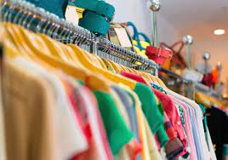
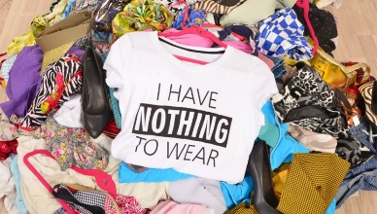
Textile waste is an unintended consequence of fast fashion, as more people buy more clothes and don’t keep them as long as they used to. Wardrobes in developed nations are full of clothes, so in order to sell more products, retailers must tempt shoppers by constantly producing new styles and outfits and convince them that the items they already have are no longer fashionable. Also, there is less need nowadays to “make do and mend”, as it is often cheaper and more convenient for the recent generations to buy a new item than have it repaired. Busy lifestyles make many people more time-poor than previous generations, and with the loss of sewing and mending skills over time, there is lack of motivation to repair our own garments. The rise of supermarket fashion that can be purchased alongside the weekly shop and the regular occurrence of seasonal sales make clothing seem “disposable” or “replaceable” in a way it didn’t use to be. And although there has been interest in moving towards a more circular model of textile production, which reuses materials whenever possible, current recycling rates for textiles are still very low. Even though there is a long-established national network of charity shops as well as increasing numbers of in-store recycling points in UK high-street stores, three-quarters of Britons still tend to throw away unwanted clothing instead of donating or recycling it.
(Words: 231)
1. | The main purpose of the text is to
 | A. | present solutions to the problem of clothing waste. | B. | describe in detail how retailers promote fast fashion. | C. | explain why fast fashion leads to clothing waste.
2. | This text could most probably be found in a
 | A. | history book. | B. | daily newspaper. | C. | fashion blog.
3. | According to the text, textile waste has increased because
 | A. | fast fashion retailers use cheap production methods. | B. | fast fashion retailers sell cheap clothes. | C. | people buy more and more new clothes.
4. | Fast fashion retailers try to
 | A. | persuade consumers to change their old clothes. | B. | reproduce older styles and outfits that are fashionable. | C. | tempt consumers into emptying their wardrobes.
5. | Recent generations seem to prefer to
 | A. | buy something new than fix something they already have. | B. | spend all their money on clothes than save it. | C. | donate all their old clothes to charities.
6. | Most people nowadays
 | A. | want to repair their clothes but have no free time. | B. | don’t like sewing or mending clothes. | C. | don’t know how to repair their clothes.
7. | Recycling rates for textiles are still very low because
 | A. | there is no interest in reusing materials. | B. | most people don’t recycle their unwanted clothes. | C. | there aren’t enough recycling points for unwanted clothes.
8. | In the text, the underlined word “constantly” means
 | A. | not often. | B. | on purpose. | C. | all the time.
9. | In the text, the underlined word “it” refers to
 | A. | supermarket fashion. | B. | clothing. | C. | textile production.
10. | A possible title for this text would be
 | A. | Fast Fashion leads to Consumption! | B. | Recycling comes with Fast Fashion! | C. | Fast Fashion is Environmentally Friendly too!

ΘΕΜΑ 2^{α}. ΛΕΞΙΚΟΓΡΑΜΜΑΤΙΚΗ
Fill each gap in sentences 11-20 with the correct word from the box below (A-J). Use each word only once.
A. | consequence | B. | generation | C. | tempt | D. | convince | E. | increased
F. | convenient | G. | rise (n.) | H. | purchased | I. | regular | J. | current

If you want to stay fit, you should exercise on a _____ basis.
Unfortunately, this year has seen a large _____ in the number of unemployed people.
Tickets must be_____ at least two weeks in advance.
People of the younger _____ seem to prefer interactive and collaborative learning.
I imagine it is very _____ that you live near the office.
Have you seen the _____ issue of the National Geographic magazine?
His doctor tried to _____ him to go on a diet.
Sales of laptops have _____ over the last few years.
He was given a traffic ticket as a _____ of running the red light.
They tried to _____ him to join the company by offering him a huge salary and a company car.

Match each underlined word in the sentences below (11-20) with a word from the box that has a similar meaning (A-J). Use each word only once. (35339)
