Lesson: History
Task: The world after war
Section:The road towards a United Europe

After studying the presentation of events from the period 1960–2020, try to complete the table below:
DATE | FACT | IMAGE
1962 |  | 
 | Launch of the customs union | 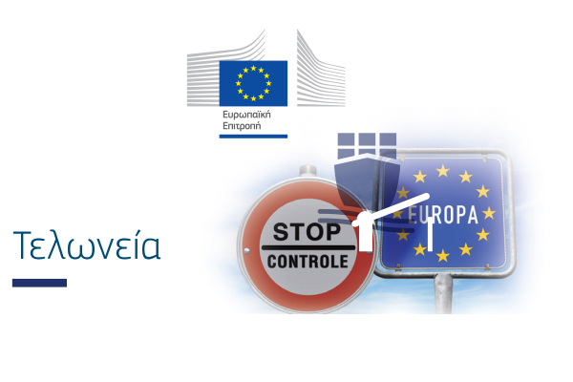
 | Holding of the first direct elections to the European Parliament | 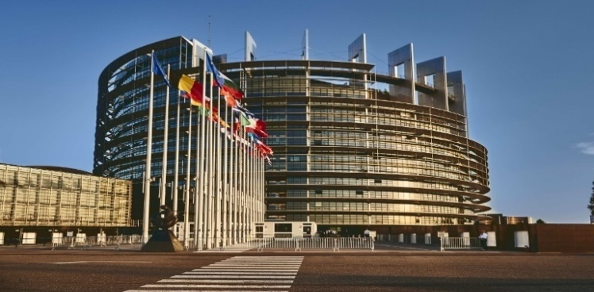
1981 |  | 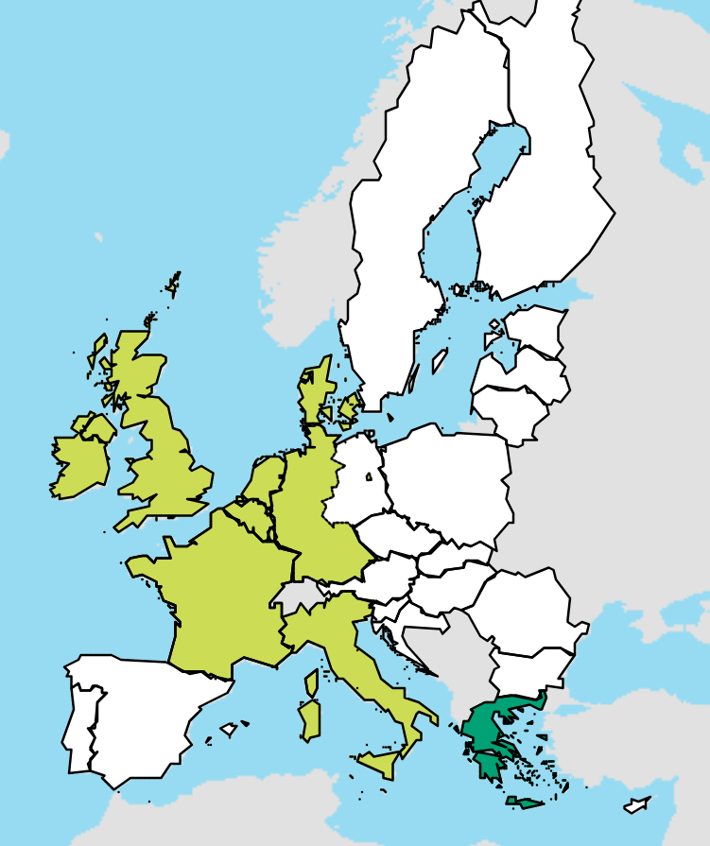
1987 |  | 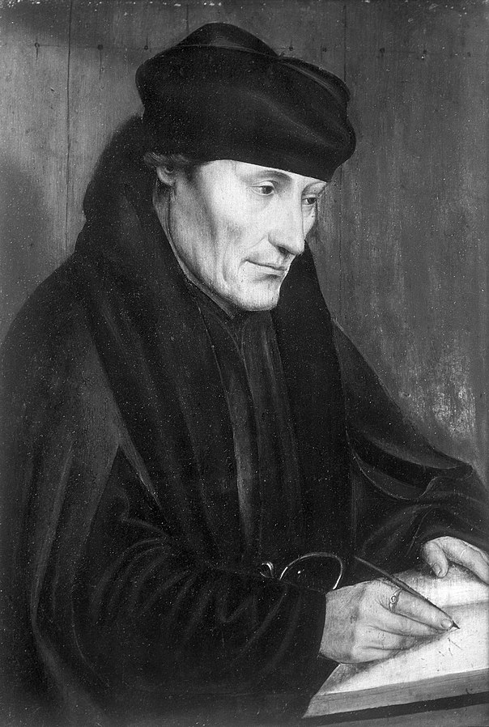
 | Maastricht Treaty & creation of the European Union | 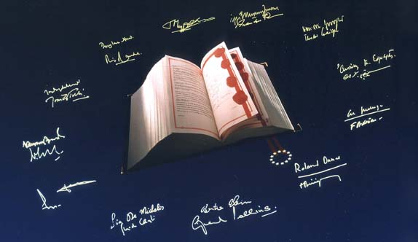
1993 |  | 
1995 |  | 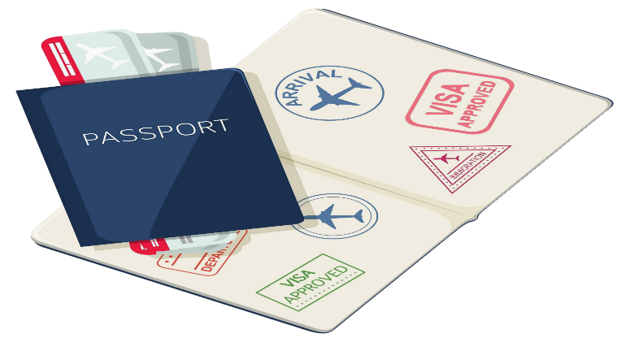
 | Euro banknotes and coins become the currency of 12 European Union countries. | 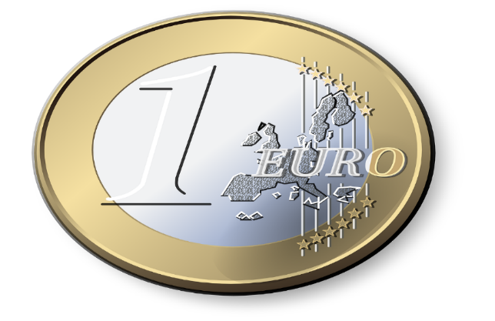
2012 |  | 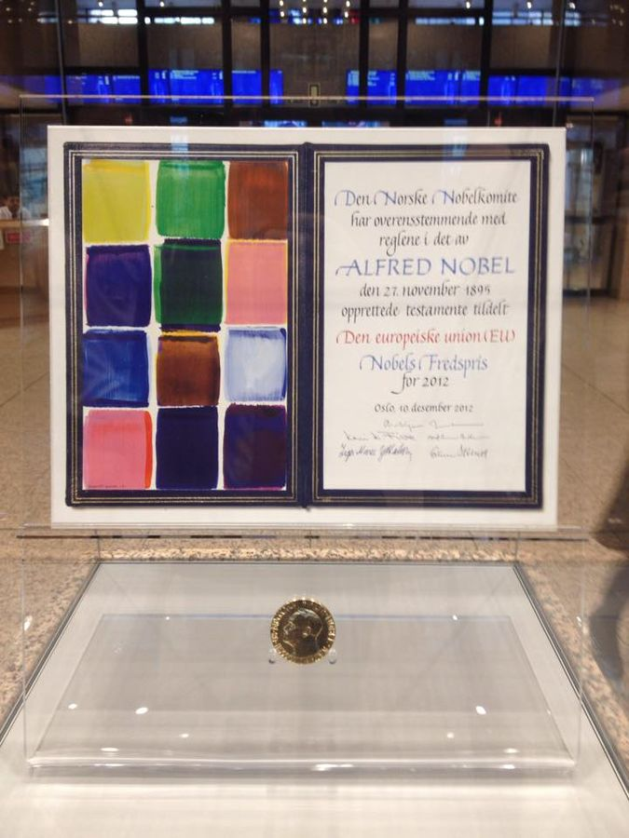
2020 |  | 