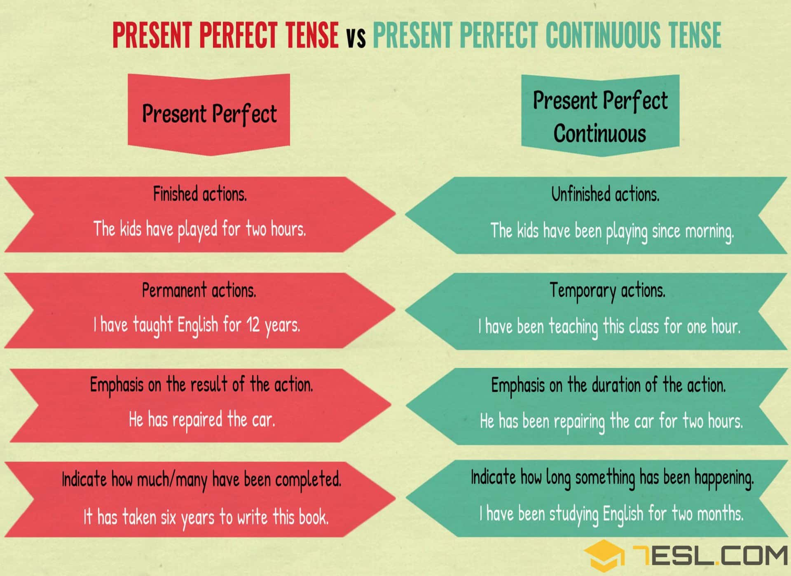

I have typed 10 letters this morning. PPS

I have been typing letters all morning. PPC

I typed 10 letters this morning. SP

PRACTICE

Complete the dialogue with the present perfect or the present perfect continuous of the verbs between brackets. Also choose ‘for’ or ‘since’ in the underlined gaps:
Robin: | I think the waiter …………………………………………… (forget) us. We ………………………………………………………….. (wait) here ……………. over half an hour and nobody ………………………………………………….. (take) our order yet.
Michele: | I think you’re right. He ………………………………………….. (walk) by us at least twenty times. He probably thinks we ………………………………………………… (order / already).
Robin: | Look at that couple over there, they ……………………………………………. (be / only) here ………………. five or ten minutes and they already have their food.
Michele: | He must realize we …………………………………………….. (order / not) yet! We …………………………………………………………. (sit) here …………….. over half an hour staring at him.
Robin: | I don’t know if he ………………………………………………. (notice / even) us. He ……………………………………………………(run) from table to table taking orders and serving food.
Michele | That’s true, and he ………………………………………………… (look / not) in our direction once.
Robin: |  | I think the waiter has forgotten (forget) us. We have been waiting (wait) here for over half an hour and nobody has taken (take) our order yet.
Michele: |  | I think you’re right. He has walked (walk) by us at least twenty times. He probably thinks we have already ordered (order / already).
Robin: |  | Look at that couple over there, they have only been (be / only) here for five or ten minutes and they already have their food.
Michele: |  | He must realize we haven’t ordered (order / not) yet! We have been sitting (sit) here for over half an hour staring at him.
Robin: |  | I don’t know if he has even noticed (notice / even) us. He has been running (run) from table to table taking orders and serving food.
Michele |  | That’s true, and he hasn’t looked (look / not) in our direction once.

