PAST SIMPLE VS PRESENT PERFECT SIMPLE

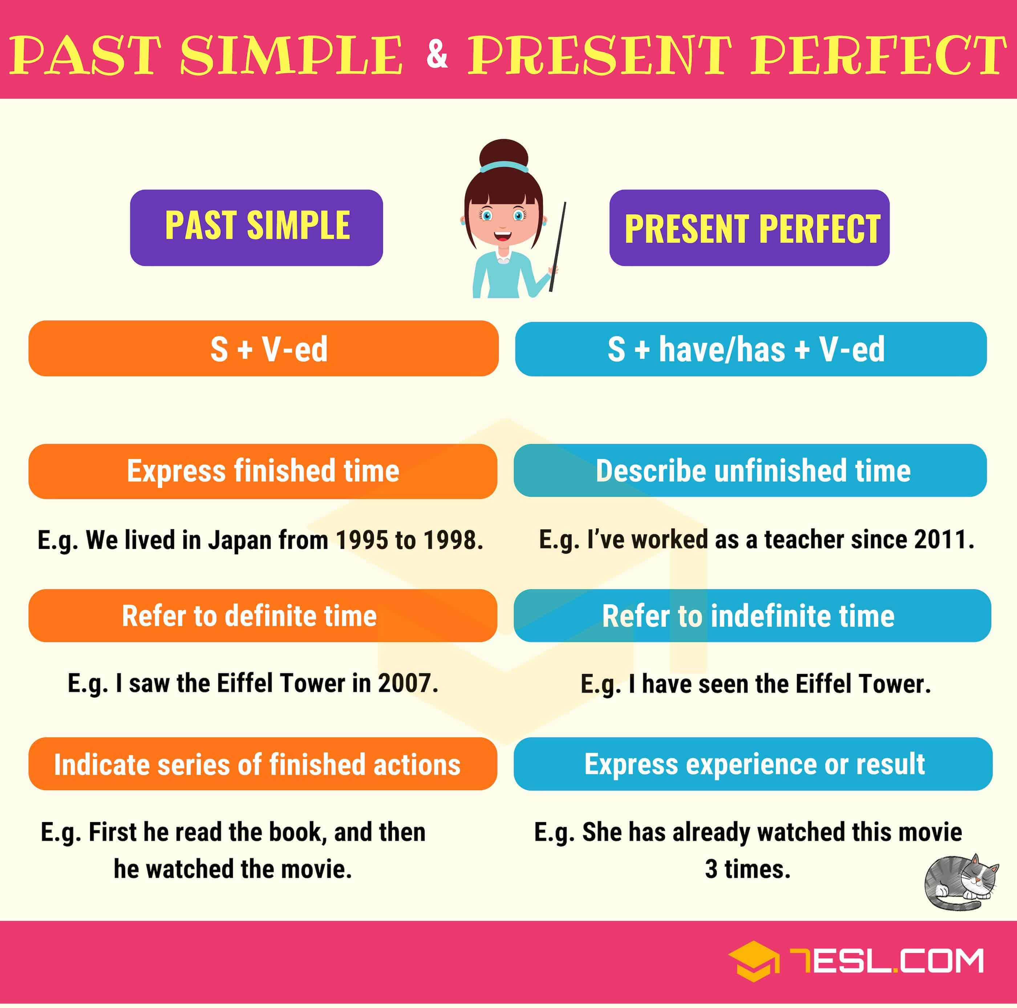

PRACTICE
COMPLETE THE SENTENCES WITH PASR SIMPLE OR PRESENT PERFECT SIMPLE

