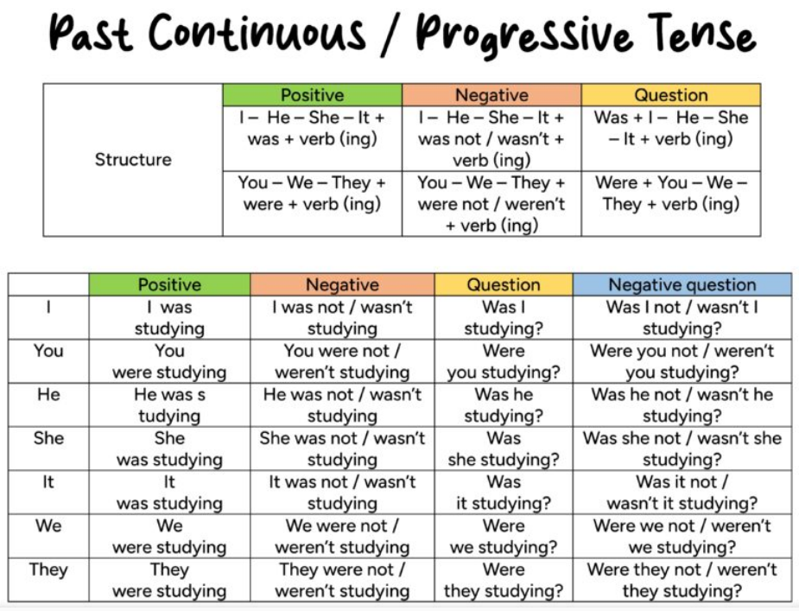

Uses of the Past Continuous Tense
- For a past action that was happening at a specific time.
I was playing videogames last night.
Simon’s dad was watering the plants at 7 o’clock.
At 5 o’clock this morning, it was snowing.
- To talk about two actions that were happening at the same time in the past.
While I was watering the plants, she was feeding the dogs.
While Megan was singing, we were dancing.
They were playing videogames while I was doing homework.

- For an action that was happening (past continuous) and was interrupted by another action (past simple).
I was cleaning the kitchen when I heard something.
Kate was playing with her cat when her mom called her.
We were having breakfast when my cousins arrived.
- To give background information about someone or something in a narrative.
Jim was at the park. People were having picnics and their kids were playing and running around.
As the sun was setting, many people gathered to take photographs of the sky.
The concert was about to start. Fans were singing and enjoying themselves.
EXERCISES
Put the verbs into the correct form (past continuous).
- When I phoned my friends, they ……………(play) monopoly.
- Yesterday at six I…………. (prepare) dinner.
- The kids …………..(play) in the garden when it suddenly began to rain.
- I ……………(practise) the guitar when he came home.
- We ……………..(not / cycle) all day.
- While Aaron ……………(work) in his room, his friends ……………(swim) in the pool.
- I tried to tell them the truth but they …………….(listen / not) .
- What ………………..(you / do) yesterday?
- Most of the time we………………….. (sit) in the park.
Fill each gap with a verb in either the past simple or past continuous tense.

1. Helen………….. (do) her weekly shopping when she ……………(meet) her old friend, June.
2. The sun ……………….(shine) when I ……………..(get) up this morning. I ………………(feel) so tired!
3. Jim …………….(wait) at one airport while Max ………………………..(wait) at the other. What a disaster!
4. It …………………..(rain) very hard, so the referee………………………….. (decide) not to play the match.
5. When the police…………… (arrive) at the party, the music ……………….(play) very loud and everybody………………… (shout).
6. The mail ………………….(arrive) very late today. It ………………..(come) after eleven o'clock.
7. Joan ……………….(become) very angry this morning. She…………………. (speak) to an important client and someone …………………….(enter) the room without knocking.
8. Hank ………………………….(cook) in the kitchen. His sister………………………… (offer) to help but Hank ……………………………(refuse).

