Present Continuous – Exercises

1. What are they doing? Look at the pictures and write sentences:
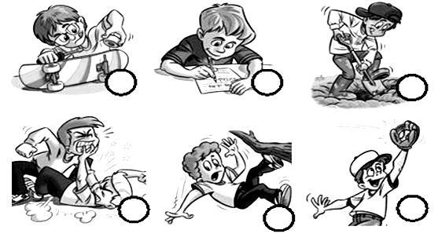

  - ________________________________________________________________.

  - ________________________________________________________________.

  - ________________________________________________________________.

  - ________________________________________________________________.

  - ________________________________________________________________.

  - ________________________________________________________________.

- Put the verb into the correct form of the present continuous:
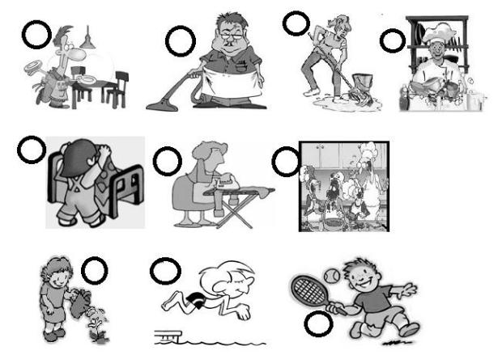

- My sister ____________________________. The floor is wet now.

- The chef ____________________________. The dishes are clean now.

- The child ____________________________. The bed is tidy now.

- My dad and my mum _________________________. The food is delicious now.

- I ____________________________. The daisy smells nice now.

- John ____________________________. The carpet is clean now.

- The boy ____________________________. He loves doing sport.

- Your uncle ____________________________. The table is ready now.

- My aunt ____________________________. Be careful! The iron is still hot.

- Sam ____________________________. He is jumping into the water now.


1

- Put the verb in brackets into the present continuous, affirmative, negative or interrogative:

    - Wow! The bus driver _________ (drive) very fast.

    - Look! They ___________________ (have) a lot of fun.

    - Oh no, they _______________ (fight).

    - Listen! Someone ____________________ (knock) on the door.

    - They _______________ (not read). They ________________ (ride) their bikes outside.

    - _________ she____________ (run)? - Yes, she is. She _________ (run) to the playground.

    - John, look outside the window. The sun _________________ (shine) again.

- Complete the sentence with the present continuous of the verb in brackets:

  - We are in the garden. My mother _________________ (water) the plants and Tom _____________ (lie) on the grass. Dad and me _______________ (play) cards and our dog ____________ (chase) our neighbours’ cat.

  - “What ___________________ (Tony/do)?” “He _______________ (surf) the

Internet now.

  - You _________________ (not/listen) to me, Sue! What ________________

(you/think) about? You look absent-minded.

  - Mary _________________ (sit) on the sofa _____________ (read) a book.

  - “Where’s your boyfriend?” “He _________________ (park) the car.”

  - The children ___________________ (not/ swim), they _____________ (run).

  - Who _____________________ (Mandy/ speak) to? I don’t know him.

  - Something strange _________________ (happen) in the street. I can hear a police car.

  - My grandmother _________________ (knit) a sweater and a pair of gloves for my brother.

  - I ________________ (write) to Sue. I _______________ (tell) her about our adventure holiday.

  - My sister ______________ (brush) her hair.

  - Paul ________________ (wash up) while his wife _____________ (iron) some trousers.

  - Sally _______________ (save) because she wants to buy some new trainers.

  - “Why _______________ (the baby/ cry)? Is he hungry?” “No, he

___________.”

  - Carol _______________ (not/ dance) with Patrick, she ____________ (drink) some coke.

  - My brother and his friend Adam ________________ (learn) to drive.

2

  - If it ______________ (not/ rain), we can go out.

  - ____________________ (Alice/ eat) a cheese or a ham sandwich?

  - Some people ________________ (wait) for the bus. Let’s join the queue!

  - Peter isn’t at home now, he ________________ (walk) the dog.

  - “_________________ (the students/ revise) for their exam?” “Yes, they

___________.”

  - We ____________ (pack) our suitcase since we ______________ (leave) for London tomorrow.

  - Who _______________ (bring) the camera? I want to take some photos of the wedding.

  - Don’t disturb Lewis! He _______________ (study) a lot to pass his maths exam.

  - Why __________________ (you/ tease) your sister, Andy? Leave her alone!

  - Can you turn the light on? It _____________ (get) dark.

- Complete the sentences with the present continuous of the verbs in brackets:

  - Mary _____________ the homework (not/do), she _____________ (listen) to music.

  - _____________ (you/ revise) for tomorrow’s exam?

  - What _____________ (Paul/wear) today?

  - “_____________ (you/ work) on Saturday, Susan?” “Yes, I _____________”.

  - The cats and the dog’s _____________ (fight).

  - Mrs Brown _____________ (iron) some shirts.

  - “_____________ (your sister/ read), Sue?” –“No, she _____________”.

  - The boy _____________ (not/swim) today.

  - Tom _____________ (sit) next to me in class.

  - “Where _____________ (you/go), Tina?” “I _____________ (go) to the dentist”.

  - My mum _____________ (not/drink) tea, she _____________ (eat) an apple.

  - Paul _____________ (jog) with his father.

  - _____________ (your brother/ work) or _____________ (study)?

  - Who _____________ (Carol/ talk) to, Alan?

3

6. Choose the correct answer:

1. What is he doing?
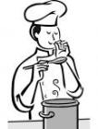

a. He is jumping b. He is playing

c. He is cooking d. He is drinking

2. What is she doing?
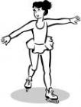

a. She is skating b. She is dancing

c. She is swimming d. She is skiing

3. What is he doing?
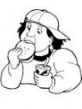

a. He is drinking b. He is watching TV

c. He is cooking d. He is eating

4. What is she doing?


a. She is cooking b. She is drinking

c. She is playing d. She is speaking

5. What is he doing?
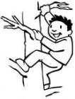

a. He is climbing b. He is riding a bike

c. He is jumping d. He is flying

6. What is he doing?


a. He is eating b. He is speaking

c. He is dancing d. He is making a cake

7. What is she doing?
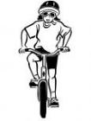

a. She is skating b. She is drinking

c. She is playing d. She is riding a bike

8. What are they doing?
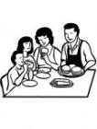

a. They are having dinner b. They are Flying a kite

c. They are watching TV d. They are sleeping

4

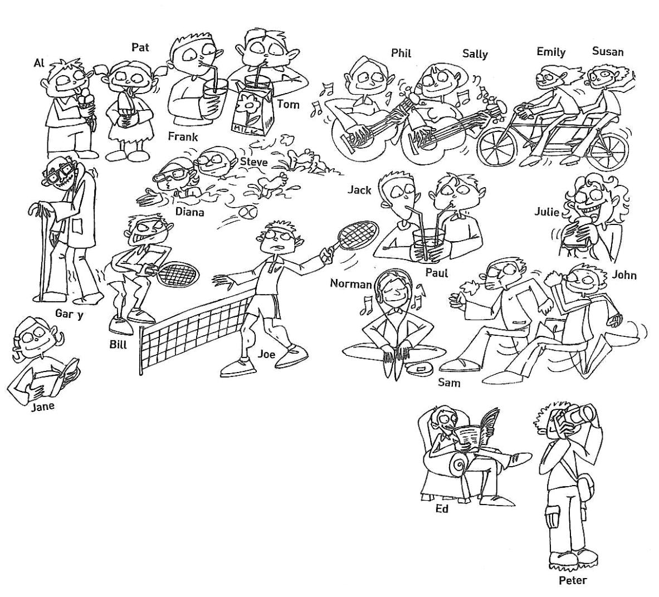

7. Who is who?

Who is who?

- He is walking. __________________________

- She is eating an ice cream.__________________

- They are swimming.____________________________________

- They are running._______________________________________

- He is taking photos.______________________________________

- She is playing the guitar.__________________________________

What are they doing?

- Julie is ______________________________________________________________

- Frank and Tom_______________________________________________________

- Bill and Joe__________________________________________________________

- Ed__________________________________________________________________

- Emily and Susan______________________________________________________

- Norman_____________________________________________________________

- Al__________________________________________________________________

Answer the questions.

- Is Bill playing tennis?_______________________________________________

- Are Jack and Paul drinking?__________________________________________

- Is Jane writing a letter?_____________________________________________

- Is Gary running?___________________________________________________

- What is Peter doing?_______________________________________________

- What are Sam and John doing?_______________________________________

- Is Susan reading?__________________________________________________

- Are Diana and Steve playing tennis?___________________________________

5

