A. circle the correct answer.
1. When you are in a library you……………be quiet. 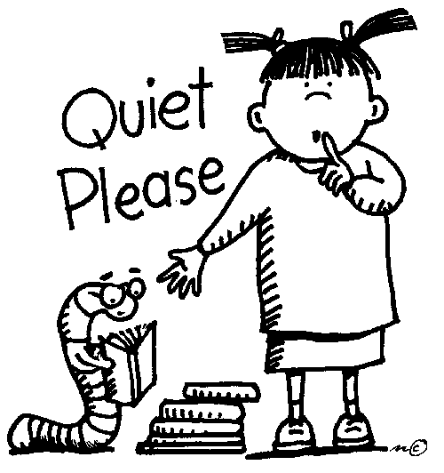
A. have to be B. don’t have to be

2. When the traffic light is red you.......................stop.  
A. Have to B. don’t have to
3. When the teacher is talking you …………………….be quiet. 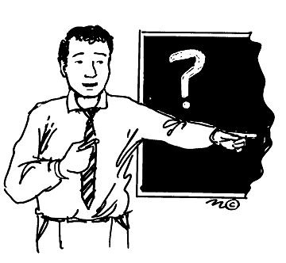
A. Have to B. don’t have to
4. When you have a quiz you…………………study. 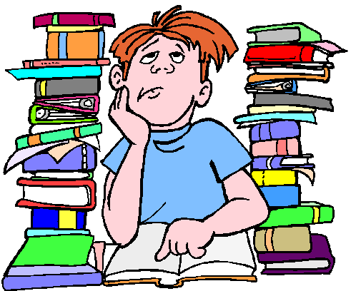
A. Have to B. don’t have to
5. When your mother is not at home you.......................cook. 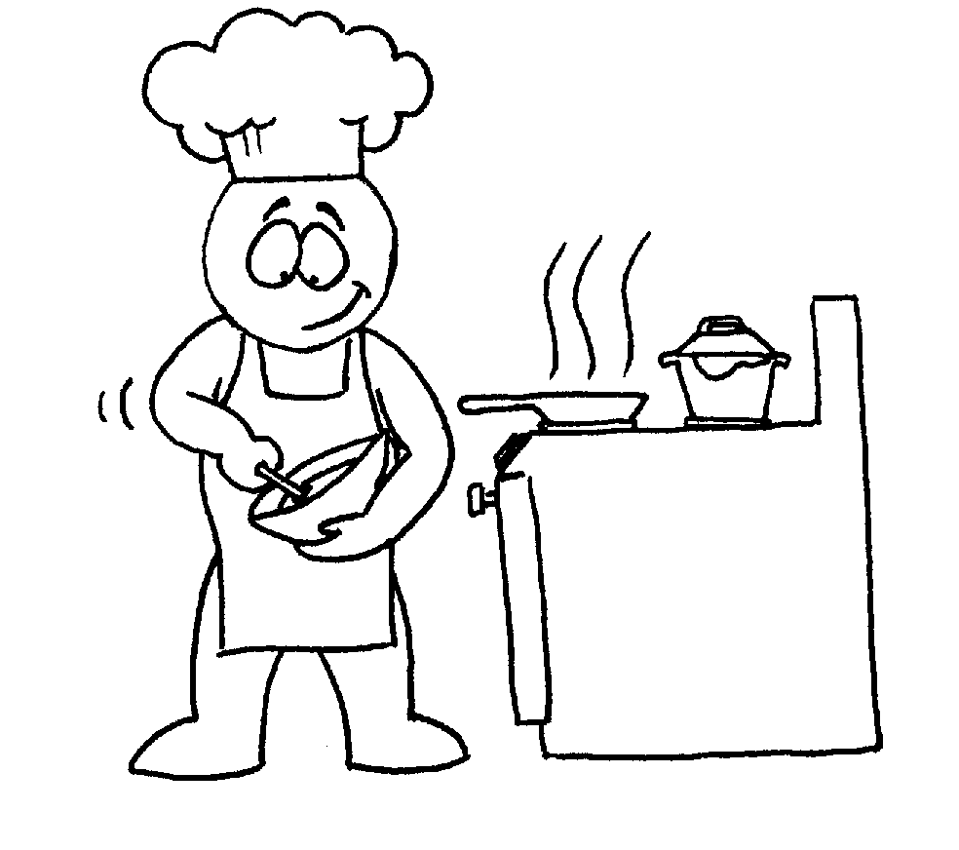
A. Have to B. don’t have to

6. When you go to school you ………………..wear a uniform .
A. Have to B. don’t have to

7. When you are sick you………………….go to school.

A. Have to B. don’t have to
8. When you are on a holiday you ……………………...do your homework.
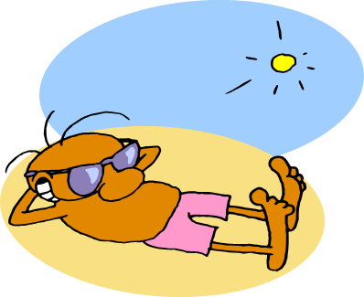
A. Have to B. don’t have to
9. Ali is a student. He ………………………..get up early.
A. Has to B. doesn’t have to
10. My father is a cook. He………………………go to the restaurant every day.
A. Has to B. doesn’t have to
11. My sister is a secretary, so she ……………………answer the telephones

A. Has to B. doesn’t have to

12. Jack is French and doesn’t know English. So Before he goes to America, he……………….go to English class.
A. Has to B. doesn’t have to
B. Fill out the table and then answer the questions
Duties
Me | My father | My mother | My sister | My brother

I have to…………………………………………………………………………………………..
My father has to…………………………………………………………………………………..
My mother has to………………………………………………………………………………….
My sister has to……………………………………………………………………………………
My brother has to………………………………………………………………………………….
C. Ask your partner then report to the class or to your teacher.
What do you have to do?
…………………………………………………………………………………………………....
What does your father have to do? ........................................................................................................................................................
What does your mother have to do? .........................................................................................................................................................
What does your sister have to do? .........................................................................................................................................................
What does your brother have to do? .........................................................................................................................................................

