QUANTIFIERS-MULTIPLE CHOICE TEST
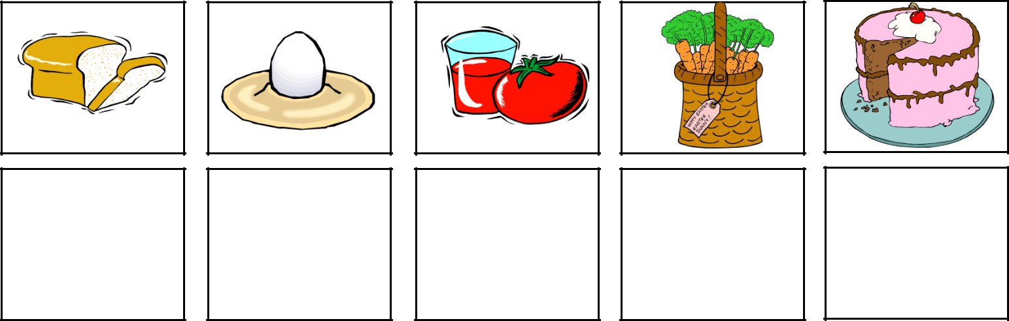

1. Would you like | 2. I eat ____ boiled | 3. Can you give me | 4. How ___ carrots
____ bread? | egg every morning. | ____ tomato juice? | do you need?
a) a slice of | a) a | a) a few | a) much
b) a bar of | b) an | b) many | b) many
c) a bunch of | c) a few | c) some | c) a few
d) a can of | d) a little | d) any | d) a little
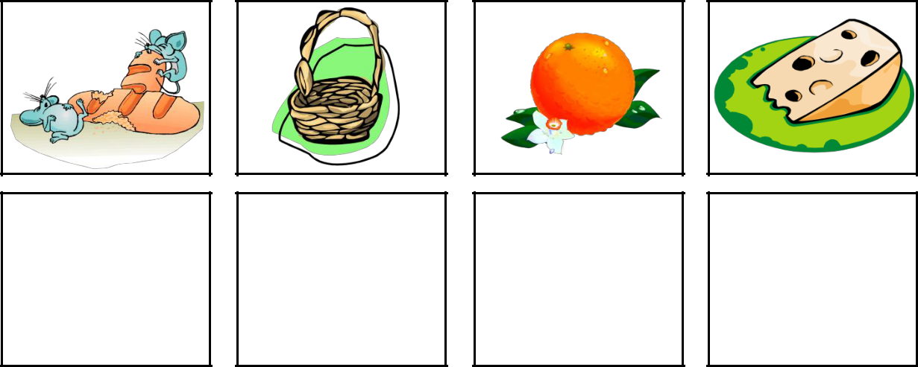

6. We have ____ | 7.There aren't ____ | 8.You should eat __ | 9.There is __cheese
bread,don't we? | egss in the basket. | orange every day. | on the plate.
a) a few | a) too much | a) a | a) some
b) a little | b) a lot of | b) an | b) many
c) too many | c) any | c) any | c) any
d) too much | d) some | d) a few | d) a few
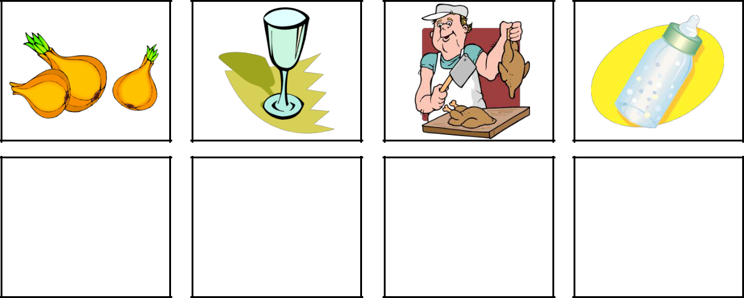

11.Please give me | 12.There isn't ____ | 13.How ___chicken | 14. There is __milk
____ onions. | water in the glass. | would you like,sir? | in the baby bottle.
a) a lot | a) a few | a) much | a) many
b) a few | b) many | b) many | b) a lot of
c) too much | c) an | c) a few | c) a few
d) a little | d) any | d) a little | d) any
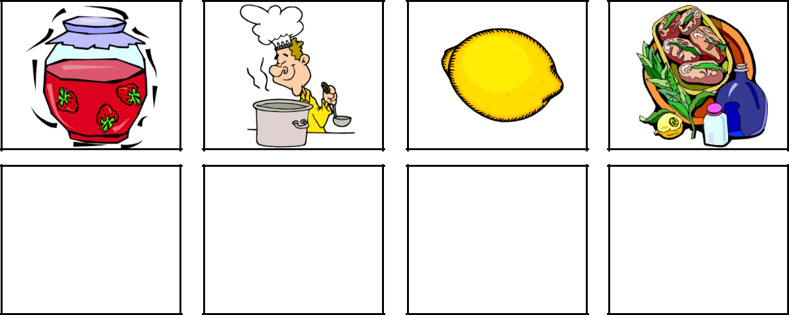

16. We have ____ | 17. Don't put ____ | 18. I'll make ____ | 19. There is ____
strawberry jam. | salt in the soup. | lemonade to drink. | food on the table.
a) a bar of | a) a few | a) a few | a) too much
b) a bottle of | b) many | b) many | b) too many
c) a jar of | c) too much | c) any | c) a few
d) a can of | d) too many | d) some | d) many

- I ate only ____

cake tonight. a) a loaf of
b) a bottle of c) a pinch of d) a piece of
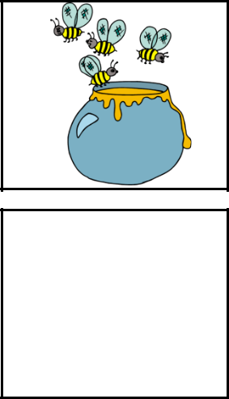

10.There is ____
honey in the pot.
- any
- many
- a lot of
- a few
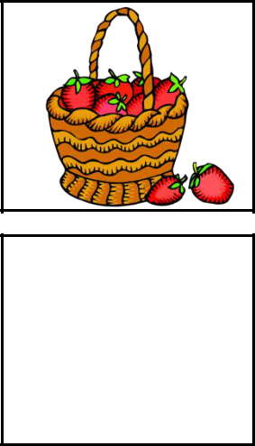

- We have ____

strawberries here. a) a little

b) a lot of c) any
d) too much
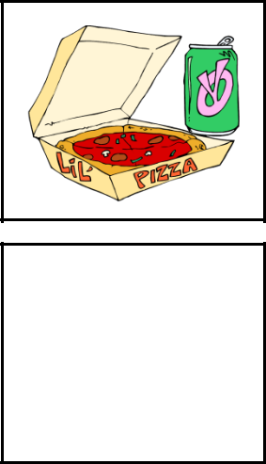

- Give me ____

coke with the pizza. a) a can of
b) a jar of

c) a bunch of d) a pinch of

Copyright © 2013. englishwsheets.com. All rights reserved.

