1.There is _____ honey in the jar.

2.There aren't _____ apples in the basket.
3.There is _____ egg on my plate.
4.There isn't _____ water in the glass.
5.There is _____ chicken and salad.
6.Let's buy _____ cheese from here.

7.There is _____ pizza in the box.
8.There isn't _____ milk in the bottle.

9.There are _____ strawberries in the cup
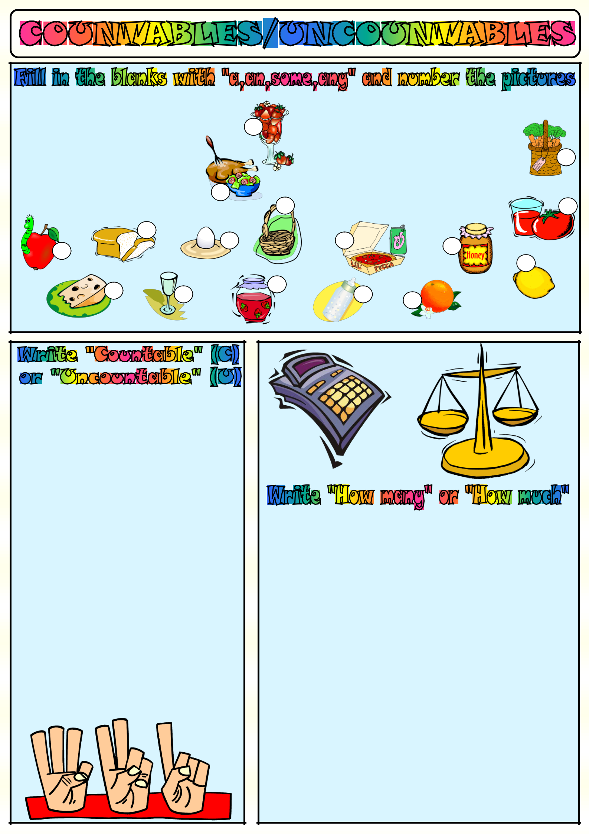
10.Do you want to eat _____ orange?
11.There is _____ tomato near the glass.
12.There is _____ jam in the big jar.
13.We don't need _____ bread today.
14.I need _____ lemon for the salad.

15.There are _____ carrots in the basket
16.Susan has got _____ apple.It's red.

1.milk | _____ | 2.cucumber | _____
3.potato | _____ | 4.cherry | _____
5.olives | _____ | 6.yoghurt | _____
7.carrot | _____ | 8.peach | _____
9.money | _____ | 10.water | _____
11.egg | _____ | 12.fries | _____
13.time | _____ | 14.oil | _____
15.sugar | _____ | 16.onion | _____
17.banana _____ 18.bread |  |  | _____
19.cheese _____ 20.lemonade |  |  | _____
21.hamburger _____ 22.orange |  |  | _____
23.coffee _____ 24.salt |  |  | _____
25.rice | _____ | 26.pencil | _____
27.chicken | _____ | 28.tea | _____
29.book | _____ | 30.love | _____
31.meat | _____ | 32.umbrella | _____
33.woman | _____ | 34.butter | _____

- ________ cans of coke do you want?
- ________ orange juice is there in your glass?
- ________ time have we got to go to school?
- ________ olive oil do you use for your cake?
- ________ money do you pay for your house rent?

- ________ people are there in that pink house?
- ________ pencils would you like to buy?
- ________ televisions are there in your house?
- ________ hamburgers do you eat a week?
- ________ bread do you eat at breakfast?
- ________ kilos of meat does she want to buy?
- ________ sugar would you like for your tea?
- ________ bananas are there in that basket?

- ________ jam is there in that big jar?

- ________ lemonade will you prepare for the party?

- ________ cars does that rich man have?
- ________ hours does Steven sleep every night?
- ________ bars of chocolate would you like?
- ________ children are playing in the garden now?
- ________ sleep does an adult need a day?
- ________ salt do you put in your soup?

- ________ t-shirts does she have in her wardrobe?

Copyright © 2013. englishwsheets.com. All rights reserved.

