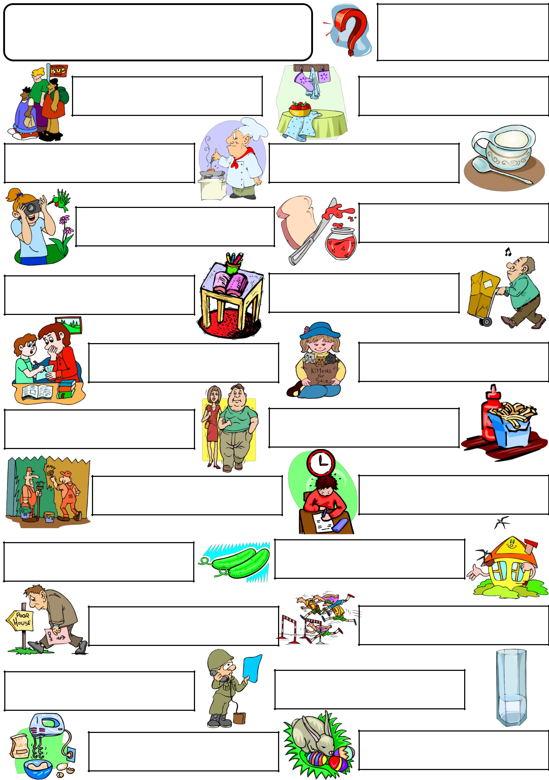
a few OR A lIttle

Fill in the blanks with "a few" or "a little" to complete the sentences.

There are ___ students at the bus stop.

The cook is putting ___ olive oil into the vegetable soup.

Ruby wants to take ___ photographs of the birds.

There are ___ coloured pencils and a book on the table.

I can see only ___ apples in the bowl.

I want ___ sugar for my tea.Can you add it,please?

I want ___ jam on my bread.I like jam and bread.

Mr.Turner is carrying ___ boxes.He doesn't need any help.

Dad,I have got only ___ homework today.Can you help me,please?

Suzy has got ___ kittens. She wants to sell them.

You are very fat,dear.You should only eat ___ bread every day.

I think I will add ___ ketchup to my chips.I like ketchup.

___ painters are painting the wall.

They are using green and yellow.

I'm having a difficult exam and I have got only ___ time.

Susan needs ___ cucumbers for the salad.

Mr.Sad is unhappy because he has got only ___ money.

Sir,I have got ___ questions about the plan.

My grandmother adds ___ flour to the omelette.

Look! ___ birds are flying over that yellow house.

___ racers are running to the finish line.

There is only ___ water in that glass.I want some more.

There are ___ easter eggs in front of the rabbit.

Copyright © 2013. englishwsheets.com. All rights reserved.

