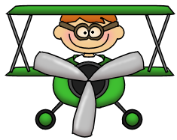


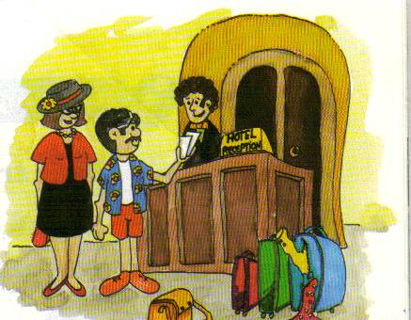
- Complete the conversation at the hotel:
help you double ten How long
a room balcony hotel enjoy luggage

Receptionist: Can I 1)____________ sir?
Tourist: Yes, please. I would like 2)_________with a bathroom.
Receptionist: A single room or a 3)________ room?
Tourist: A double room. With a 4)__________.
Receptionist: I have got a double room with a balcony.
Tourist: Perfect.
Receptionist: 5)__________ are you staying?
Tourist: A week.
Receptionist: Alright sir. Your room is number 6)_________. The porter is going to help you with the 7)______. Welcome to our 8)________. I hope you will 9)________ your stay.

- Write the corresponding caption in the picture:

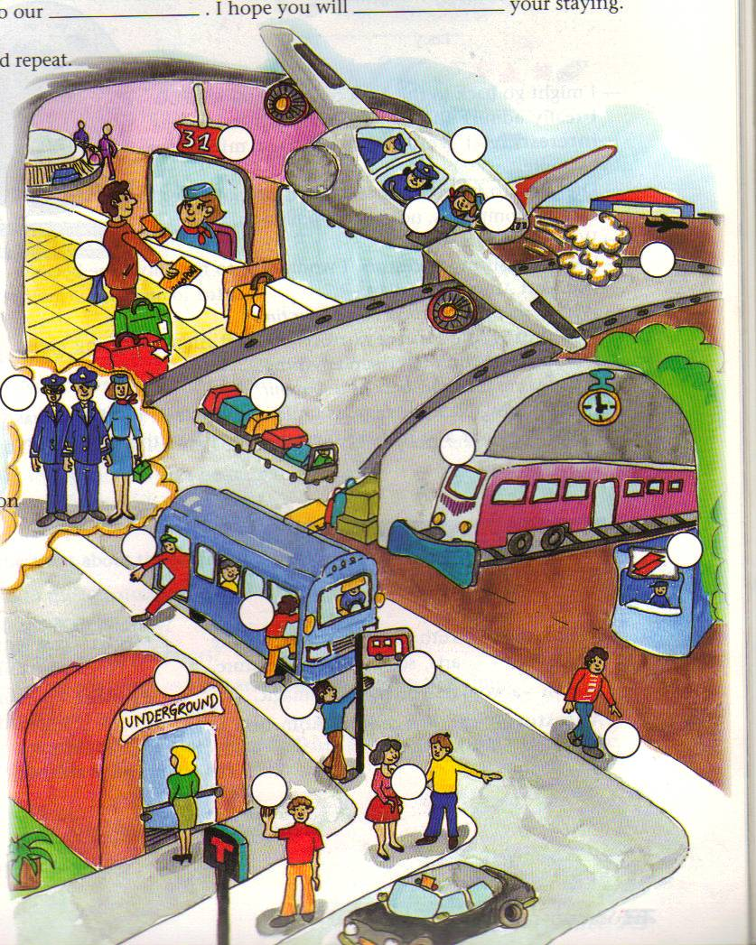
- Get off
- Bus stop
- to walk
- ticket office
- To ask the way
- Get a taxi
- Check-in
- To take the bus
- Underground station
- Passenger
- Get on
- Train station
- Pilot
- Crew
- Luggage
- Airport
- Air hostess
- Aeroplane
- Passport

