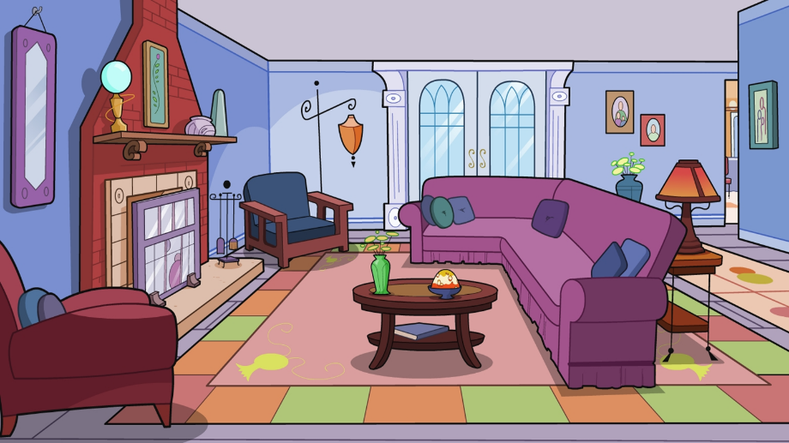
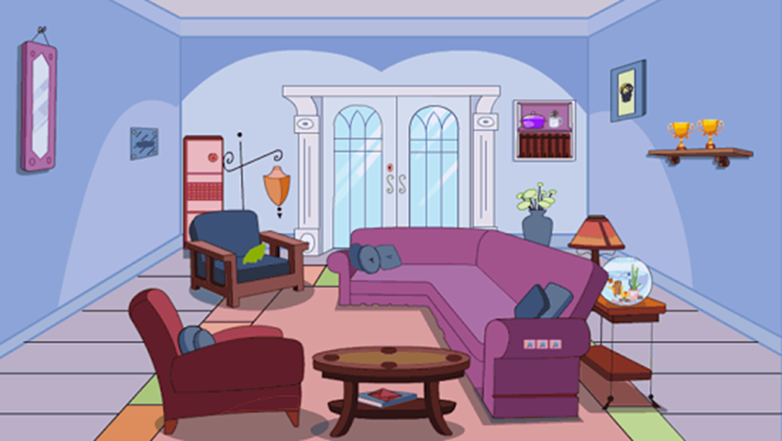
Look at the both pictures and say which picture, A, B or both, is described.

1. There is a fireplace. A B both
2. There is a small table behind the sofa. A B both
3. There is a goldfish behind the sofa. A B both
4. There is a coffee table in the room. A B both
5. There are some pictures on the wall. A B both
6. There are some books. A B both
7. There isn’t a television in the room. A B both
8. There are two trophies in the room. A B both
9. There are two armchairs in the room. A B both
10. There is a mirror on the wall. A B both
11. There is a small vase on the table. A B both
12. There is a rug in the room. A B both
13. There is a floor lamp next to the armchair. A B both
14. There isn’t a computer in the room. A B both
15. There are some cushions on the sofa. A B both
16. There is a service table in the room. A B both
Answer these questions.
1. Is there a coffee table in the room?
2. Is there a computer?
3. Are there any books in the room?
4. Is there a fireplace?
5. Are there any pictures on the wall?
6. Is there a television?
7. Is there a vase on the table?
8. Are there any cushions on the sofa?
B
A
Put there is, there isn’t, there are or there aren’t into the blanks.
1. ____________ a coffee table in the room.
2. ____________ a vase on the table.
3. ____________ some books in the room.
4. ____________ some cushions on the sofa.
5. ____________ any children in the room.
6. ____________ a computer in the room.

There is / There are

