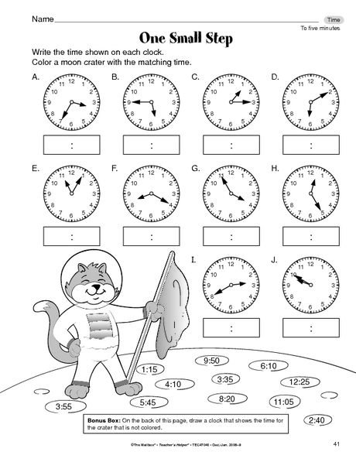
1. Check the right time.

a. It’s twenty-five to three. a. It’s a quarter to six. a. It’s a quarter to two.
b. It’s twenty-five past three. b. It’s a quarter past five. b. It’s a quarter past three.
c. It’s twenty-five to four. c. It’s a quarter to five. c. It’s a quarter past one.

F
E

a. It’s half past two. a. It’s twenty past four. a. It’s twenty past eleven.
b. It’s ten past six. b. It’s eight past four. b. It’s five past four.
c. It’s six past ten. c. It’s twenty past eight. c. It’s five to four.

I
G

a. It’s five past eleven. a. It’s twenty-five to twelve. a. It’s ten past ten.
b. It’s ten to one. b. It’s twenty-five past twelve. b. It’s ten to eleven.
c. It’s one past eleven. c. it’s twenty-five past five. c. It’s ten to ten.

2. What time is it?
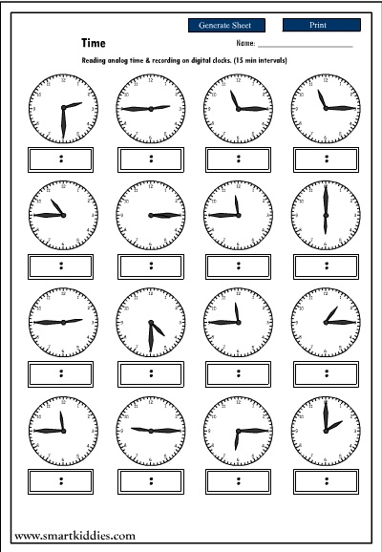
a. b. c. d.

a.________________________________________________
b.________________________________________________
c.________________________________________________
e. f. g. h.

e. _______________________________________________
f.________________________________________________
g.________________________________________________
h.________________________________________________

i. j. k. l.

i._______________________________________________
j._______________________________________________
k._______________________________________________
l._______________________________________________

