The season when we celebrate Easter

1
Easter is always celebrated on ……
3
7
1

6
2


3
4

The Friday before Easter Sunday
5

6

11
7

8
10
9


11

10

The fourth month of the year
The period of forty days before Easter

5
8
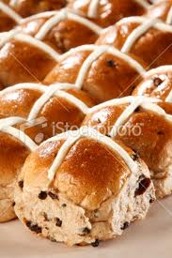
4
2
9

