Exercise 1: Complete the sentences with the correct countries or nationalities.
- Carlos is from Spain. He is ____________________________ .
- Peter is from Canada . He is ___________________________.
- Pamela is American. She is from __________________________ .
- Juan is Mexican. He is from ____________________________ .
- Martha and Fernandez are from Brazil. They are ____________________________ .
- John’s family is from the UK. They are _________________________ .
- Chinua Achebe is an African writer. He is from __________________________ .
- Pedro is from Italy. He is __________________________ .
- My French teacher is from __________________________ .
- Samantha is from Germany. She is _______________________________ .
Exercise 2: Complete the tables with the correct countries or nationalities.
ELENI  Country: Greece  Nationality:______________________  Age : 16 | NICHOLAJ  Country: _____________________  Nationality: Russian  Age: 29 | COSTAS  Country: Cyprus  Nationality:__________________  Age: 18
AHMED  Country: Turkey  Nationality:______________________  Age: 26 | MELA  Country:____________________  Nationality: Egyptian  Age: 13 | JAVET  Country: India  Nationality:__________________  Age: 22
KIRA  Country: China  Nationality:______________________  Age:18 | MIYIAKI  Country: Japan  Nationality:___________________  Age: 34 | ANASTASIA  Country: _____________________  Nationality: Australian  Age: 17

Exercise 3: Write the correct country under each flag . Use the countries in the box to help you.
THE U.S.A - CHINA - MEXICO - GREECE - TURKEY - RUSSIA -
THE UNITED KINGDOM (UK) - ITALY

1.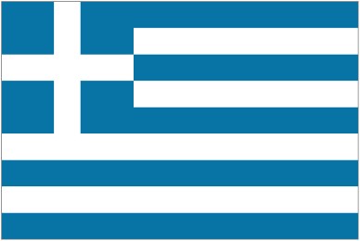 _____________________ 2. 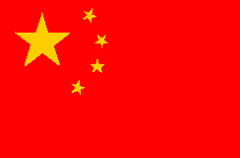 _____________________

3.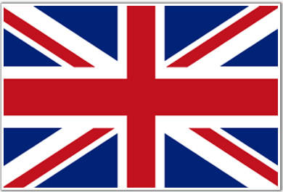 ______________________ 4. 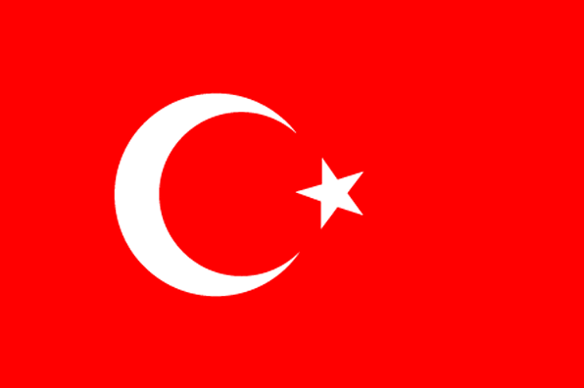 _______________________

5. 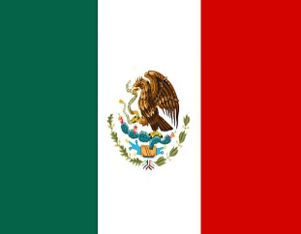 _______________________ 6. 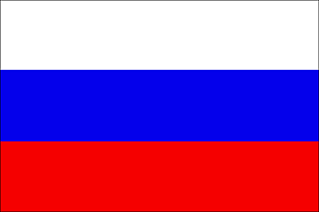 _______________________

7. 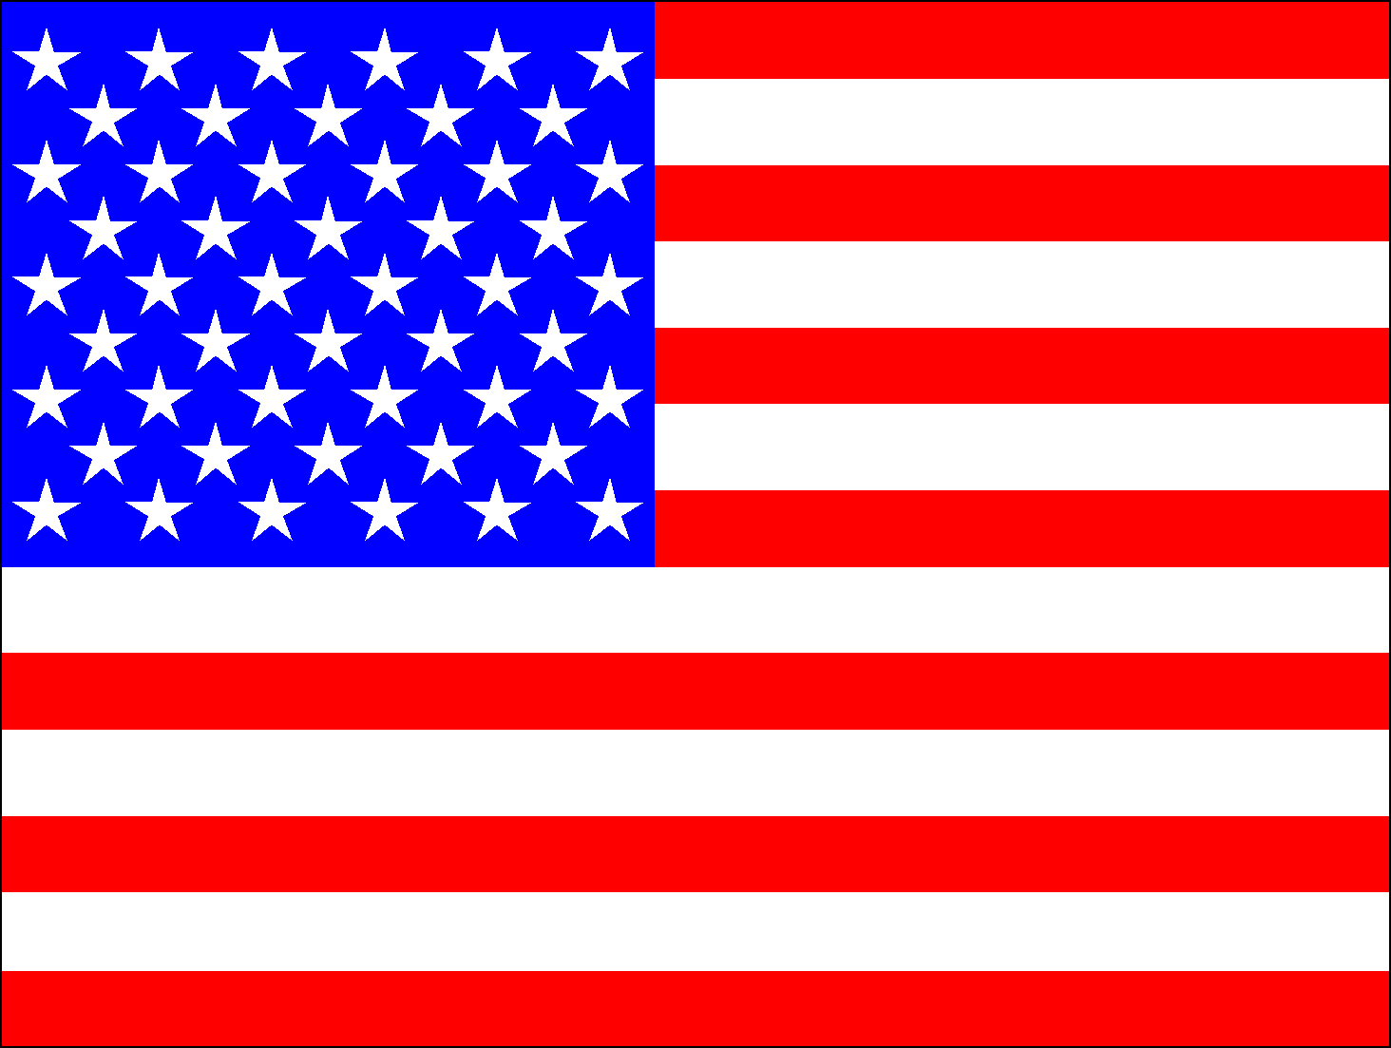 _______________________ 8.  

