
1. For verbs that end in -O, -CH, -SH, -SS, -X, or -Z we add -ES in the third person.

- go – goes
- catch – catches
- wash – washes
- kiss – kisses
- fix – fixes
- buzz – buzzes

2. For verbs that end in a consonant + Y, we remove the Y and add -IES.

- marry – marries
- study – studies
- carry – carries
- worry – worries



1. If the base verb ends in consonant + vowel + consonant, double the last letter:
- Stop - Stopping
- Run - Running
- Begin - Beginning

2. If the base verb ends in ie, change the ie to y:
- Lie - Lying
- Die - Dying

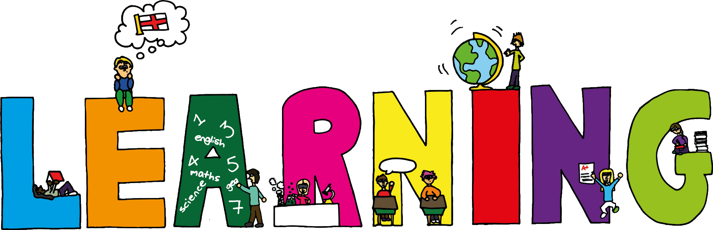
3. If the base verb ends in vowel + consonant + e, omit the e:
- Come – Coming
- Mistake - Mistaking

