UNIT 6

1. Tick the means of communication mentioned in the dialogue.
- the Internet √ : "And what exactly is the Internet?"
- cable TV -
- CD-ROM √ "First of all, a CD-ROM. What's that?"
- e-mail √ "...but how does that differ from an e-mail?"
- satellite TV -
- fax √ "Now, what about a fax?"

Task 2: Matching Definitions Answer Key with Explanations
a) a means of sending and receiving printed material in electronic form along a phone line
- Answer: fax (or a fax / fax machine)
- Explanation: Peter asks: "Now, what about a fax? I know that we use it to send or receive printed material down the phone line in an electronic form."
b) a network which allows computer users to communicate with each other around the world
- Answer: the Internet
- Explanation: Susan explains: "Well, it’s a network which allows computer users from anywhere in the world to communicate with each other..."
c) a means of storing information on a disc to be read by a computer
- Answer: a CD-ROM (or CD-ROM)
- Explanation: Susan states: "A CD-ROM. Well, it’s a way of keeping information on a disk which can be read by a computer."
d) a system which allows messages to be sent and received by a group of computer users
- Answer: e-mail (or an e-mail)
- Explanation: Susan mentions: "Well, the e-mail is a system which is mainly used by computer users, and messages can be sent from computer to computer..."
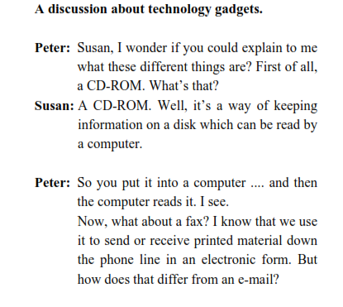
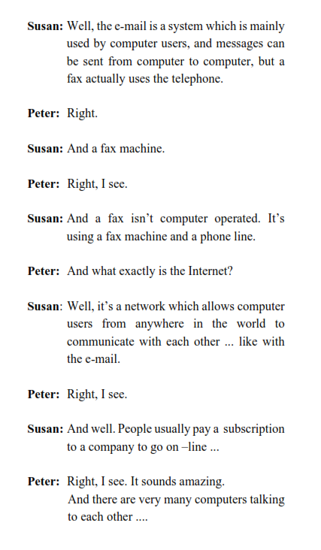

UNIT 7

Listening: True or False Answer Key with Explanations
1. Sara started smoking when she was seven.
- Answer: F
- Explanation: Sara says: "I’m 17. I started smoking when I was ten."
2. She thinks it’s easy for young kids to get hold of cigarettes.
- Answer: T
- Explanation: Sara says: "It’s really easy for kids to get hold of cigarettes if they want to."
3. Young people start smoking because they are influenced by tobacco adverts.
- Answer: F
- Explanation: Sara says: "I don’t think people start smoking because they are influenced by adverts. I think the main reason is peer pressure."
4. If your friends smoke and you don’t, you feel you don’t belong to the group and you aren’t accepted by your peers.
- Answer: T
- Explanation: Sara says: "When you’re young, it’s very difficult not to smoke if all your friends smoke. You feel you aren’t one of the group."
5. Parents who smoke set a bad example to their children.
- Answer: T
- Explanation: Sara says: "It is also possible to start smoking if your parents smoke as well. You see them smoking as you grow up, and you think it’s a normal thing to do."
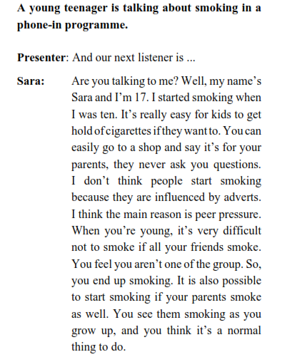

UNIT 8

Unit 8 Listening: True or False Answer Key with Explanations
1. David Beckham was born on March 2nd, 1975 in Leyfonstone, London.
- Answer: F
- Explanation: In the text, Beckham states: "Well, I was born on May 2nd 1975, in Leyfonstone, in London." (He was born in May, not March).
2. His father influenced him into becoming a fan of Manchester United.
- Answer: T
- Explanation: In the text, Beckham states: "Well, that was because of my dad. He always supported Man. United and he took me to their matches..."
Τέλεια, αυτή είναι η συνέχεια! Εδώ είναι οι σωστές απαντήσεις True (T) ή False (F) για τις προτάσεις 3 έως 8 της Unit 8 (David Beckham), βασισμένες απόλυτα στο κείμενο της συνέντευξης και έτοιμες για αντιγραφή:
3. He started his football career playing for local football teams and taking part in local tournaments at the age of eight.
- Answer: T
- Explanation: Beckham states: "Well, it all started when I was eight. I was playing at a local team and we won the tournament..."
4. At the age of 12 he took part in a tournament and won with the highest score ever.
- Answer: F
- Explanation: Beckham states: "...and at eleven I took part in a football skills tournament and I won the highest score ever..." (He was 11, not 12).
5. He wasn't a good student because all he did was to kick the ball around.
- Answer: T
- Explanation: Beckham states: "As far as I can remember myself, I was always kicking a ball. That's why I never did all that well at school."
6. When he was eighteen, he went to play for Junior Manchester United.
- Answer: F
- Explanation: Beckham states: "I failed when I was sixteen and went to play for M.U.'s Jr Team." (He went at 16, not 18).
7. By 1996 he was a regular with Manchester United.
- Answer: T
- Explanation: Beckham states: "...and by 1996 I was a regular with the team."
8. A very important year for his career was when the National Team of England advanced to the quarter-finals of the 2003 World Cup.
- Answer: F
- Explanation: Beckham states: "Well, a very important year for me was 2002 when the National Team of England advanced to the quarter-finals of the World Cup..." (It was the 2002 World Cup, not 2003).

