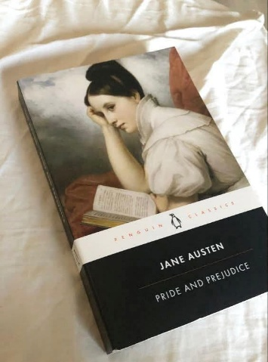
PRIDE & PREJUDICE: Book Review

I thought I knew what I was getting into with Jane Austen's "Pride and Prejudice" – some quaint romance about people in fancy clothes finding husbands. I've never been more spectacularly wrong.
From that first razor-sharp sentence about wealthy bachelors needing wives, I realized Austen wasn't writing a love story – she was wielding irony like a weapon. This wasn't going to be the literary equivalent of a costume drama. This was going to draw blood.
Then Elizabeth Bennet walked onto the page and demolished every expectation I had. In a world where women's security depended entirely on making advantageous marriages, here was a woman who rejected not one but two proposals that would have secured her future. When she verbally eviscerates Darcy's arrogant first proposal ("You could not have made me the offer of your hand in any possible way that would have tempted me to accept it"), I missed my subway stop, too electrified by her courage to notice we'd reached my station.
What knocked me sideways wasn't the romance, though that slow-burn emotional striptease is masterfully crafted. It was Austen's psychological brutality. She understood human self-deception centuries before we had terms for cognitive biases. Reading Elizabeth's realization "Till this moment I never knew myself" after learning she'd completely misjudged both Darcy and Wickham, I sat stunned in a coffee shop, suddenly aware of all the people I'd dismissed based on first impressions.
Every character cut me differently. Mrs. Bennet – ridiculous but desperately trying to secure her daughters' futures in the only way allowed. Mr. Bennet's witty detachment masking fundamental parental failure. Charlotte Lucas sacrificing love for security. And Darcy – whose journey from insufferable pride to vulnerable humanity left me wrecked.
This isn't some dusty romance – it's psychological warfare disguised as drawing-room comedy. Austen hides revolutionary ideas inside a conventional marriage plot. She creates in Elizabeth a woman who refuses to compromise her dignity even facing potential poverty. She gives us in Darcy a man whose love manifests not in flowery speeches but in concrete actions to protect Elizabeth's family, even those he disdains.
I keep my copy bedside now, not as some romantic totem but as a kind of accountability partner. When I make swift judgments about others, I hear Elizabeth acknowledging, "I, who have prided myself on my discernment!" When I'm tempted toward cynical withdrawal, I think of Mr. Bennet's regrets.
Approach with caution. This novel will charm you, gut you, change you – and smile politely the entire time.

