mikos= int(input("Δώσεμήκοςmexri 10m: "))
platos= int(input("Δώσεπλάτοςmexri 10 : "))
emvadon = mikos*platos
if (emvadon<20):
print("the room is very small", emvadon)
elif (emvadon<40)
print("the room is very small", emvadon )
elif (emvadon<60)
print("the room is very small", emvadon )

else:

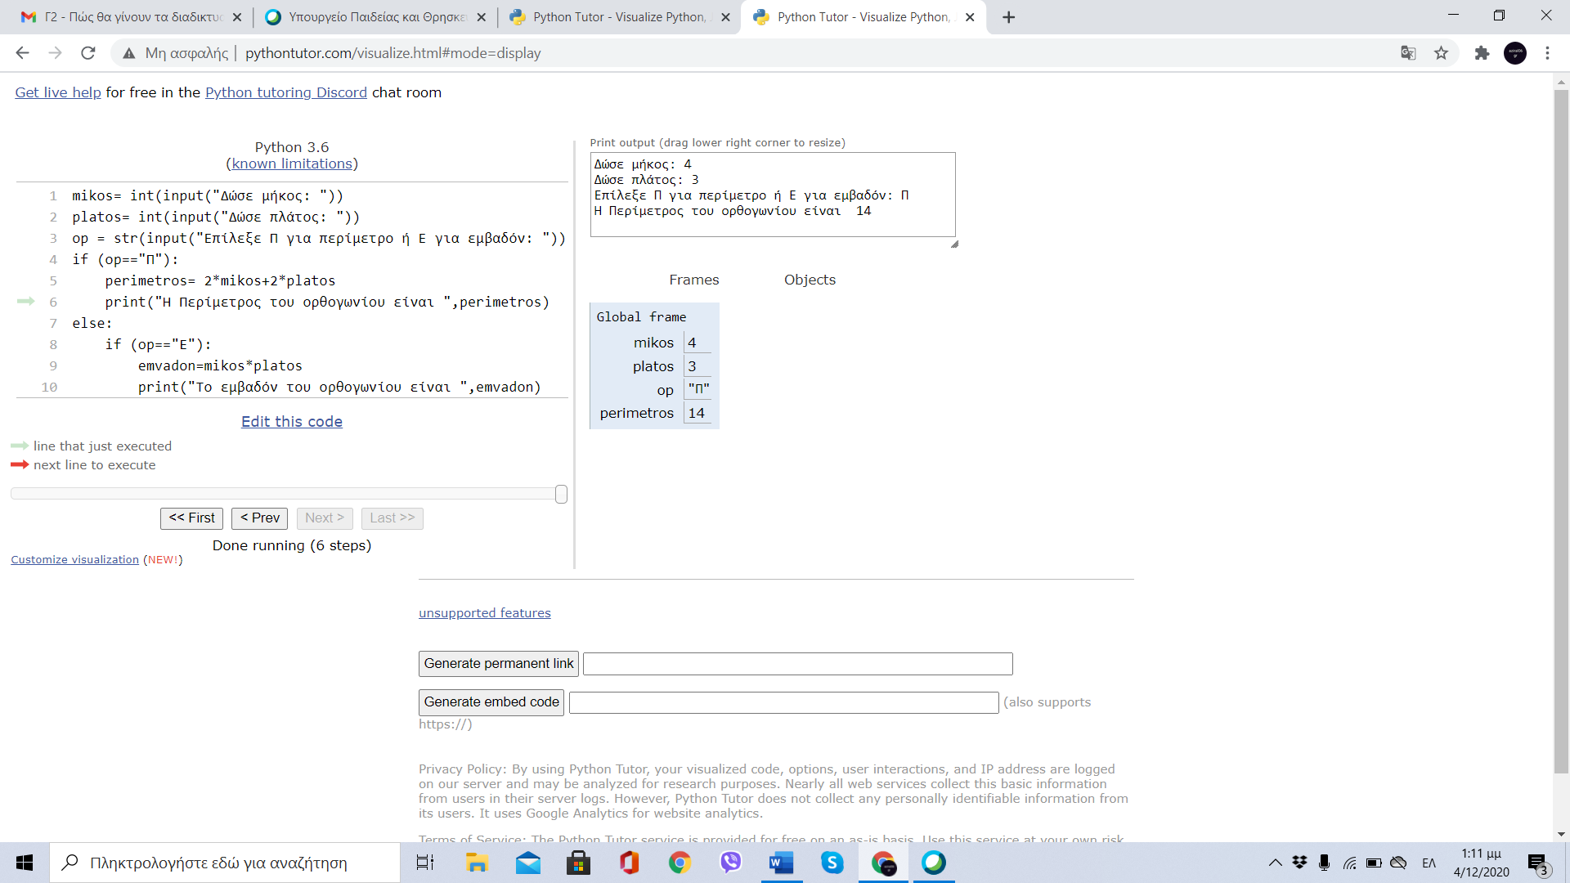

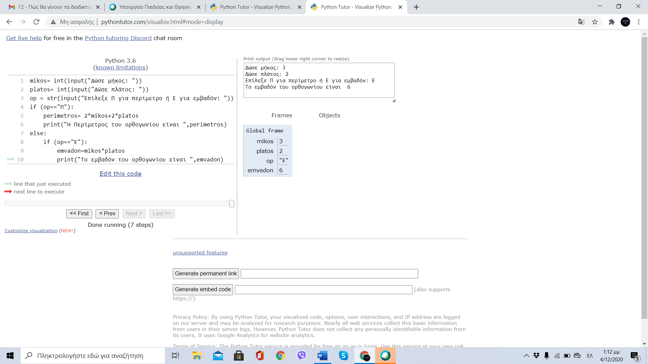

Γιώργος Χάλκος Γ2

