Worksheet 2 – Netiquette Matters! | Learning to Use the Internet Safely
“The Internet is becoming the town square for the global village of tomorrow.”
— Bill Gates
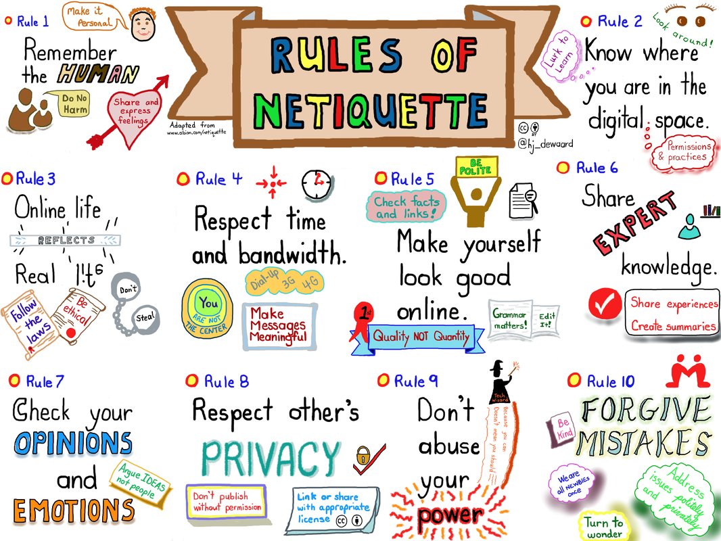
Αυτή η φωτογραφία από Άγνωστος συντάκτης με άδεια χρήσης CC BY

Purpose:
To understand how we can use the Internet in a smart and safe way by learning the rules of online behavior (Netiquette), and to write your own rule using clear English.

What will you do in this activity?
- Watch a short video about online behavior (Netiquette) to understand the concept.
- Read and explore an interactive presentation on internet safety.
- Work with a partner to write a rule for responsible internet use.
- Post your rule on a shared digital board and read the ideas from your classmates.

Why are we doing this?
Because we all use the Internet every day—for learning, fun, and socializing. Knowing how to behave online is just as important as in real life. Let’s learn how to be responsible digital citizens!
Step 1: Watch the video
What is Netiquette?
Link: Your teacher will show it in class.
While you watch, think:
- What does “Netiquette” mean?
- Why are online rules important?
Step 2: Read and explore
Go to the interactive presentation:
https://photodentro.edu.gr/v/item/ds/8521/6209
As you read, try to answer:
- What are some online threats or risks?
- How can we avoid them?
- What should we always do to stay safe online?
Step 3: Write your Netiquette Rule
With your partner, create one rule for using the Internet safely and respectfully. Use clear and simple English. You can start like this:
- “Always…”
- “Never…”
- “You should…”
- “Remember to…”
Use the space below to plan your rule:
🖊️ My Netiquette Rule:

Step 4: Share it online
Post your rule on the shared class board:

Feel free to add a picture, emoji or symbol to make your post more interesting!

Class Reflection
- Read your classmates' rules.
- Which rule do you agree with the most? Why?
- What new idea did you learn from another group?
Key Vocabulary
Word | Meaning (in your own words)
Netiquette
Online safety
Cyberbullying
Digital footprint
Responsible user

How will your teacher assess you?
Your teacher will check:
- How clearly you explain your rule.
- How well you work with your partner.
- If your rule shows understanding of internet safety.
- Your participation in the online board and discussion.

Let’s build a better, safer online world—together!

